

USER INTERFACE DESIGN 23CSE113 LAB
MANUAL

SUBMITTED BY
NAME | V.Gopal
ROLL NO | AV.SC.U4CSE25249
YEAR/SEM/SECTION | 1ST YEAR/ SEM-2/CSE-C
CREDITS | 03

SUBMITTED TO | DR. RAJ KUMAR BATCHU
DESIGNATION | ASST.PROFFESSOR (Sl. Grade)
DEPARTMENT | SCHOOL OF COMPUTING

INDEX

S.NO | TITLE | PAGE NO | REMARKS
1 | WEEK 1:  a)Installation of VS Code tool. b)Understanding basic of html structure. c)Understanding basic html tags. | 3-10
2 | WEEK 2:  Design a basic webpage with heading, paragraph, pre, table by adding styles. | 11-13
3 | Week 3:  - Create a class timetable using HTML elements.  b)Create an HTML webpage that to display syllabus of all the subjects as an image format also the timetable. | 14-24
4 | Week 4:  - Design a registration form using HTML tags.  b)Design two different forms in one webpage using Iframes. | 25-33
5 | Week5:  a)Create a card layout using <div> tag. Consider three cards and a button for each card, using HTML, and CSS.  b)Create a mini website using iframe with navigation (Home, About, Contact) that display content in the same page.  - Design an amrita login page showing different campuses on the homepage. On clicking each campus, display campus details on the same page using HTML and CSS to design stylish webpage. | 34-51
6 | Week6:  A.Design a responsive e-commerce application using the grid layout. This application should contain different categories of products such as electronics, clothing, home-appliances, books.  B: Design a responsive e-commerce application using the grid layout. This application should contain  different categories of products such as electronics, clothing, home-appliances, books. Based on the  category we select corresponding products should be  displayed on the sidebar
7
8
9
10

WEEK -1

- AIM: Steps to install VS CODE

PROCEDURE:
STEP-1
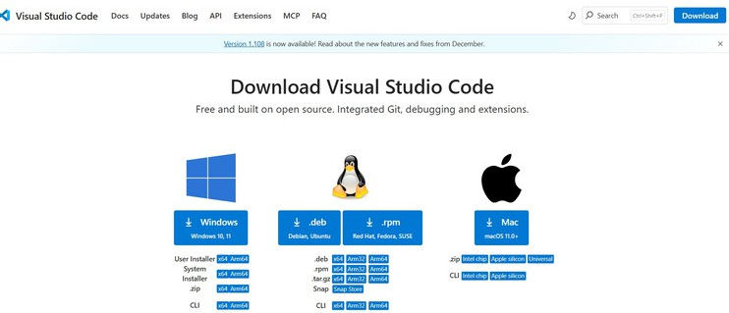

STEP-2
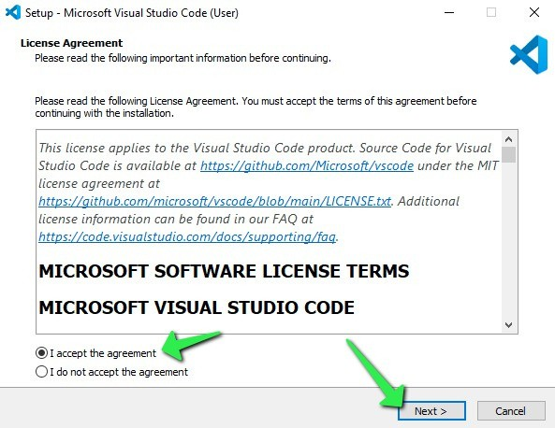

STEP-3
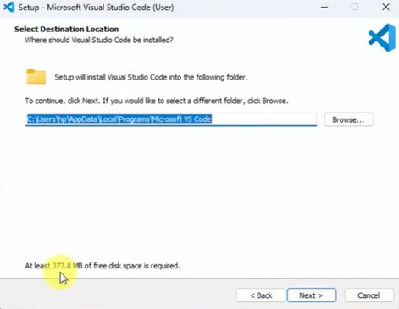

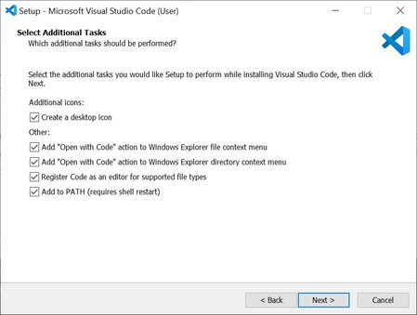
STEP-4
STEP-5
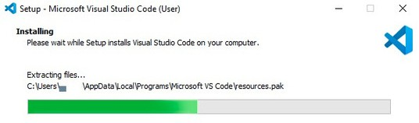

STEP-6
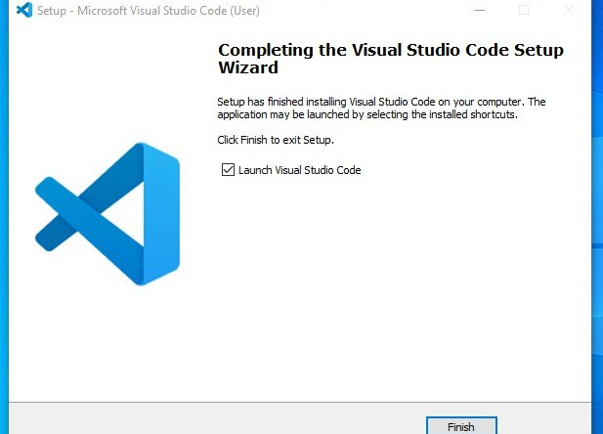

STEP-7
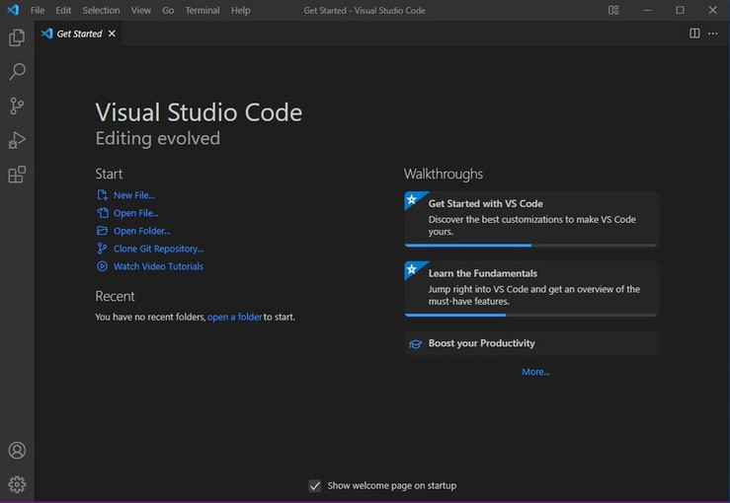

- Aim : To learn the basics of html( basics.html)
Program:
<!DOCTYPE html>
<html>
<head>
<title>First Web Page</title>
</head>
<body>
<h1>HAppy To LEarn HTML</h1>
<p>THis is my first sample code</p>
</body>
</html>
Output:

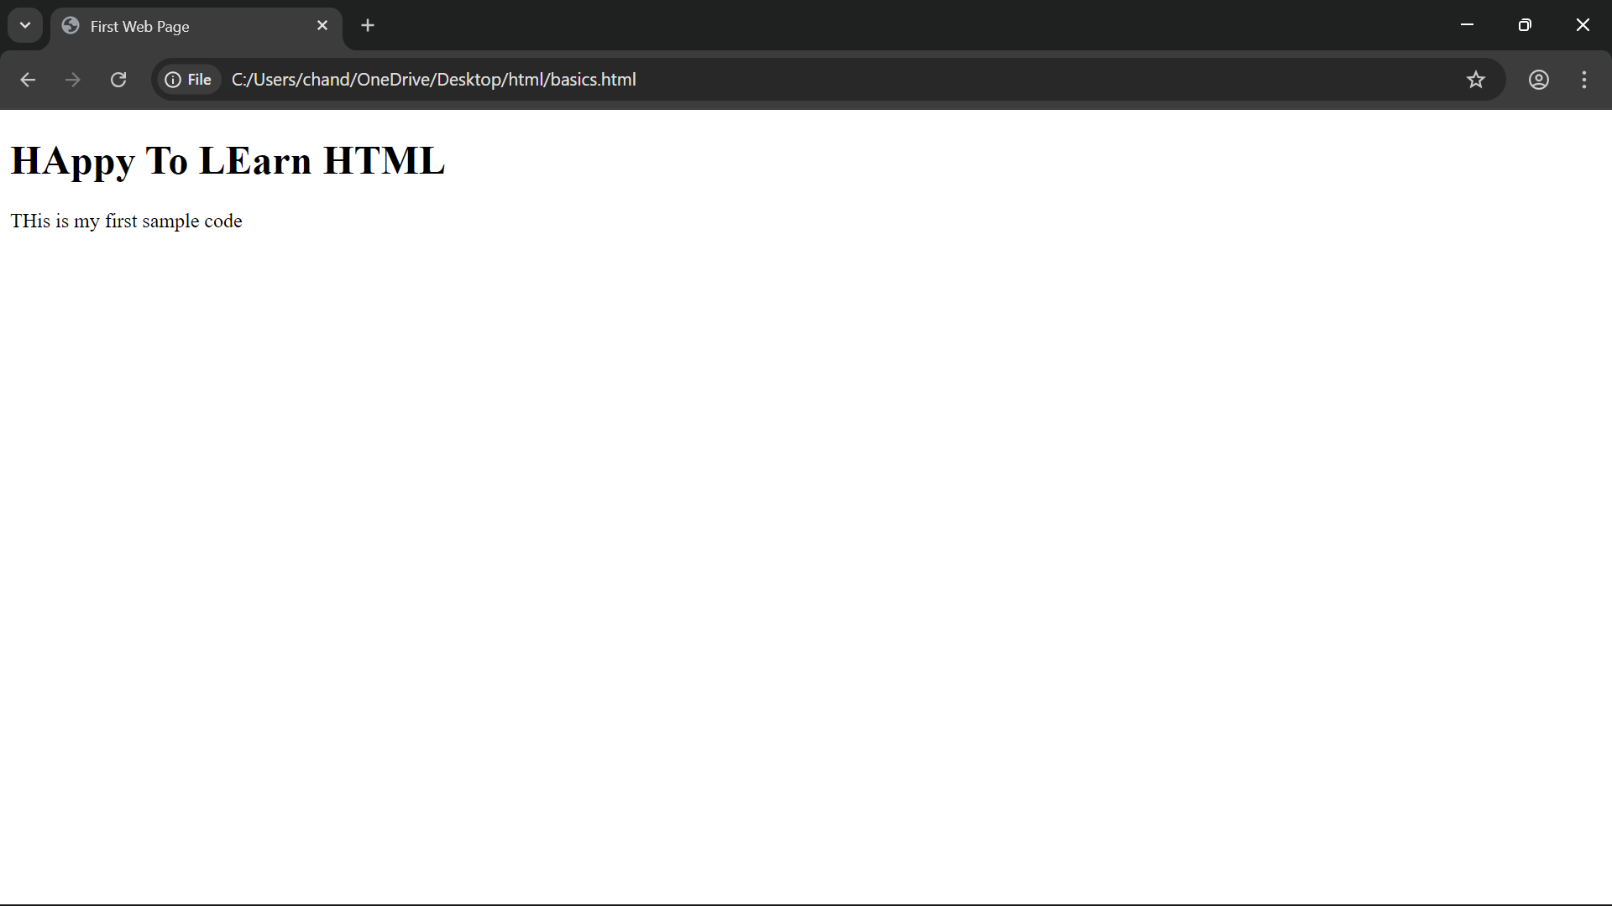
Explanation of the tags:

HTML stands for Hyper Text Markup Language. HTML is used to create and structure web pages.
It tells the web browser what to display and how to display it.
<DOCTYPE HTML> : The <DOCTYPE html>element tells the browser , this is an HTML5 document
<html>: The <html> element is the root element of an HTML page.
<head>: The <head> element contains meta information about the HTML page.
<title>: The <title> element specifies a title for the HTML page.
<body>: The <body>element contains all visible content like text
,images ,links ,tables ,etc.
<h1>: The <h1> element defines a large heading.
<p>: The <p> element defines a paragraph.

Aim : understanding basic html tags. Tags - <p>; <h1>; <img>;<color>
Program:

<!DOCTYPE html>
<html>
<head>
<title>STUDENT DETAILS</title>
</head>
<body>
<h1>MY DETAILS</h1>
<p>NAME:Gopal</p>
<p>ROLL NO:25249</p>
<p>SECTION:CSE-C</p>
<p>UNIVERSITY:AMRITA</p>
</body>
</html>

Output:

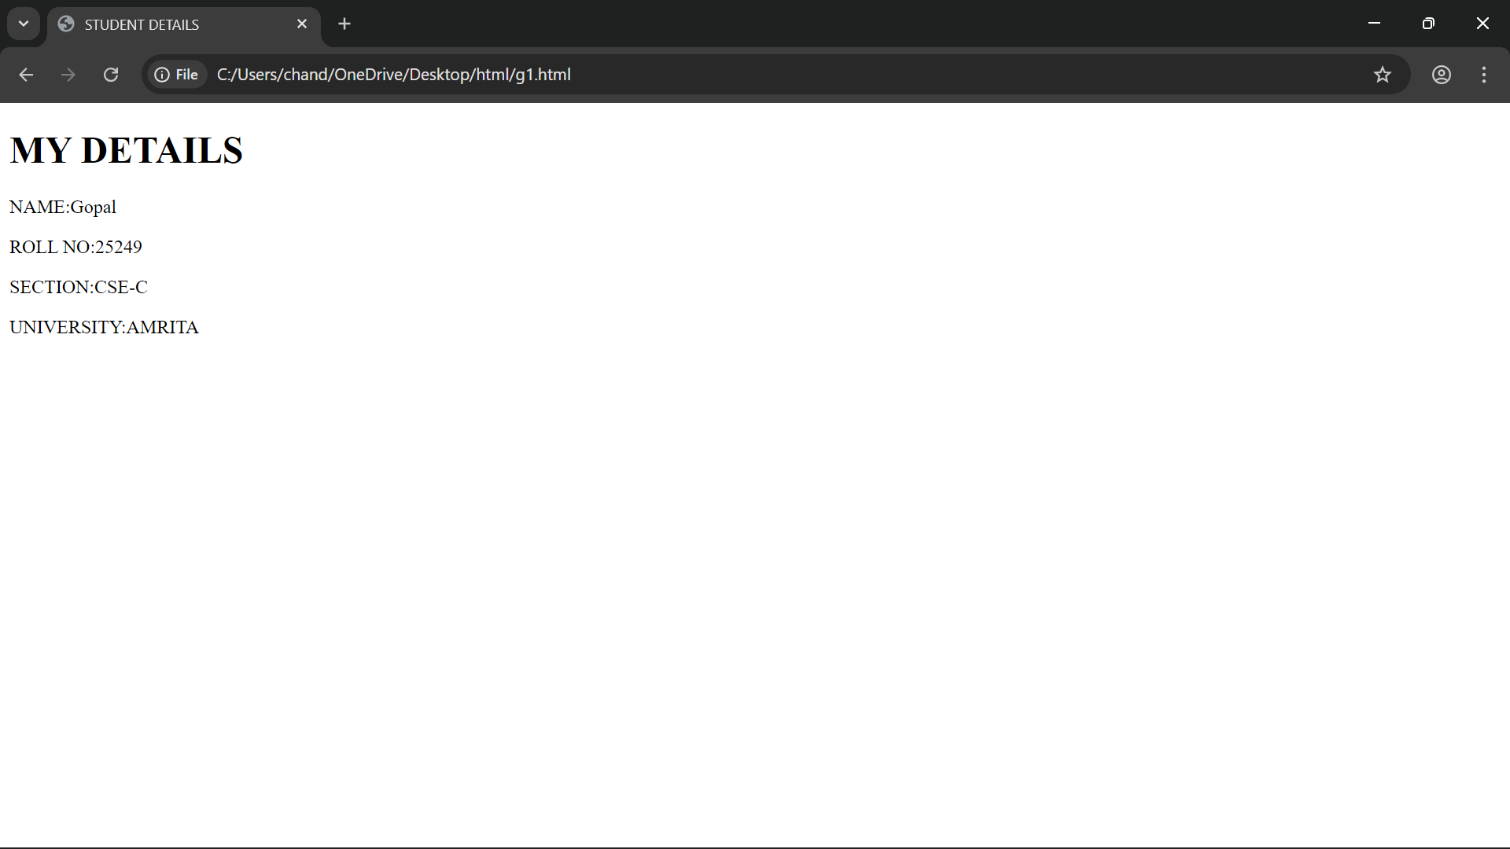

4.Aim : understanding basic html tags.

Program:

<!DOCTYPE html>
<html>
<body>
<h2 style="color:red;">HTML LINKS</h2>
<p>DEEMED <br> TO BE UNIVERSITY <br> </p>
<p><a href="https://www.amrita.com">Visit amrita</a></p>
<img src="https://img.youtube.com/vi/KVAeHggWKfo/maxresdefault.jpg" alt="https://img.youtube.com/vi/KVAeHggWKfo/maxresdefault.com" width="104" height="143">
<p>DEEMED <br> TO BE UNIVERSITY <br> </p>
<p><a href="https://www.vit.com">Visit vit</a></p>
<img src="https://upload.wikimedia.org/wikipedia/en/c/c5/Vellore_Institute_of_Technology_seal_2017.svg" width="104" height="143">
<p>DEEMED <br> TO BE UNIVERSITY <br> </p>
<p><a href="https://www.srm.com">Visit srm</a></p>
<img src="https://upload.wikimedia.org/wikipedia/en/7/7a/SRM_Institute_of_Science_and_Technology_Logo.svg" width="104" height="143">

</body>
</html>

Output:

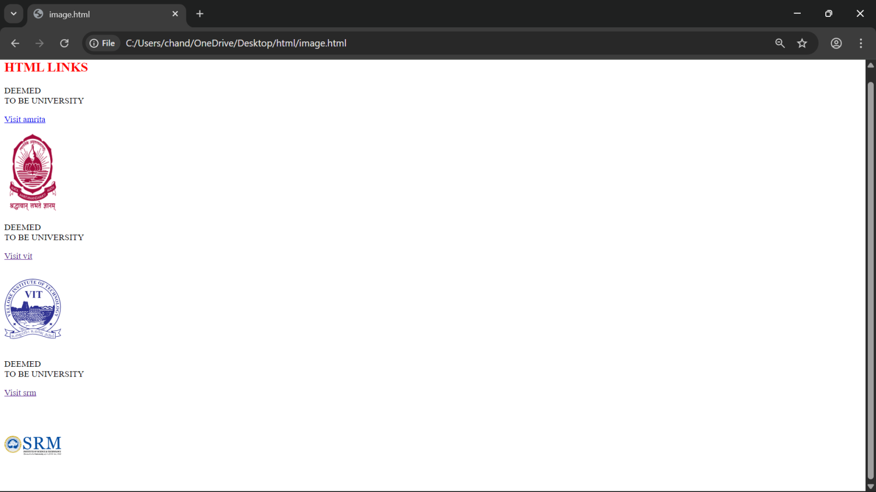
Explanation of the tags:

<br>: The HTML <br> element defines a line break. it is an empty tag with no end tag
Style: The HTML style attribute is used to add styles to an element such as color, font, size and more
<img> : The <img> tag is a fundamental HTML element used to
embed an image into a web page
<a> : The HTML <a> tag ,which stands for “anchor”, is used to define a hyperlink.

WEEK-2
Aim: Design a basic webpage with heading, paragraph, pre, table by adding styles.
Program:
<html>
<head>
<title>example web page</title>
</head>
<body background=" C:\Users\chand\Downloads\campus.jpeg" style="text-align: center;">
<hr style="color:rgb(73, 248, 42);">
<h1 style="color:red;text-align:center;">AMRITA VISHWA VIDYAPEETHAM</h1>
<hr style="color:white;">
<pre style="color:white;font-style:italic;text-align:center;">
Sri mata amritanandamayi Devi (born sudhamani Idamannel; 27 september 1953),<br>
often know as amma("mother"), is an indian hindu spiritual leader, godwoman,<br>
guru and humanitiarian.she is the chancellor of amrita vishwa vidyapeetham,<br>
a multi-campus research university.
</pre>
<table width="900" border:"2" cellpadding="30" cellspacing="15" align="center" background="campus.jpeg">
<caption style="background-color: rgba(90, 240, 190, 0.974);color:rgb(102, 47, 47);">AMRITA VISHWA VIDYAPEETHAM BRANCHES</caption>
<tr>
<th style="background-color:white;color:red;font-style:italic;">S.NO</th>
<th style="background-color:white;color:red;font-style:italic;">Campus</th>
<th style="background-color:white;color:red;font-style:italic;">Location</th>
<th style="background-color:white;color:red;font-style:italic;">Contact No</th>
<th colspan="2" style="background-color:white;color:red;font-style:italic;">Contact Person</th>
</tr>
<tr>
<td style="background-color:deepskyblue;"><b>1</b></td>
<td style="background-color:deepskyblue;"><b>Amaravati Campus</b></td>
<td style="background-color:rgb(238, 241, 34);"><b>Kuragallu</b></td>
<td rowspan="2" style="color:orange;background-color:black;">9865784585</td>
<td style="background-color:violet;">Rajkumar</td>
<td style="background-color:brown;">Batchu</td>
</tr>
<tr>
<td style="background-color:rgb(238, 241, 34);"><b>2</b></td>
<td style="background-color:deepskyblue;"><b>Amritapuri Campus</b></td>
<td style="background-color:rgb(238, 241, 34);"><b>Amrita Nagar</b></td>
<td colspan="2" style="background-color:violet;text-align:center">Adithya Ram</td>
</tr>
<tr>
<td style="background-color:rgb(34, 241, 48);"><b>1</b></td>
<td style="background-color:deepskyblue;"><b>Coimbatore Campus</b></td>
<td style="background-color:rgb(238, 241, 34);"><b>Ettimadai</b></td>
<td rowspan="2" style="color:rgb(19, 12, 1);background-color:orange;">9231184586</td>
<td style="background-color:violet;">Aashish</td>
<td style="background-color:brown;">B</td>
</tr>
</table>
</body>
</html>

Output:

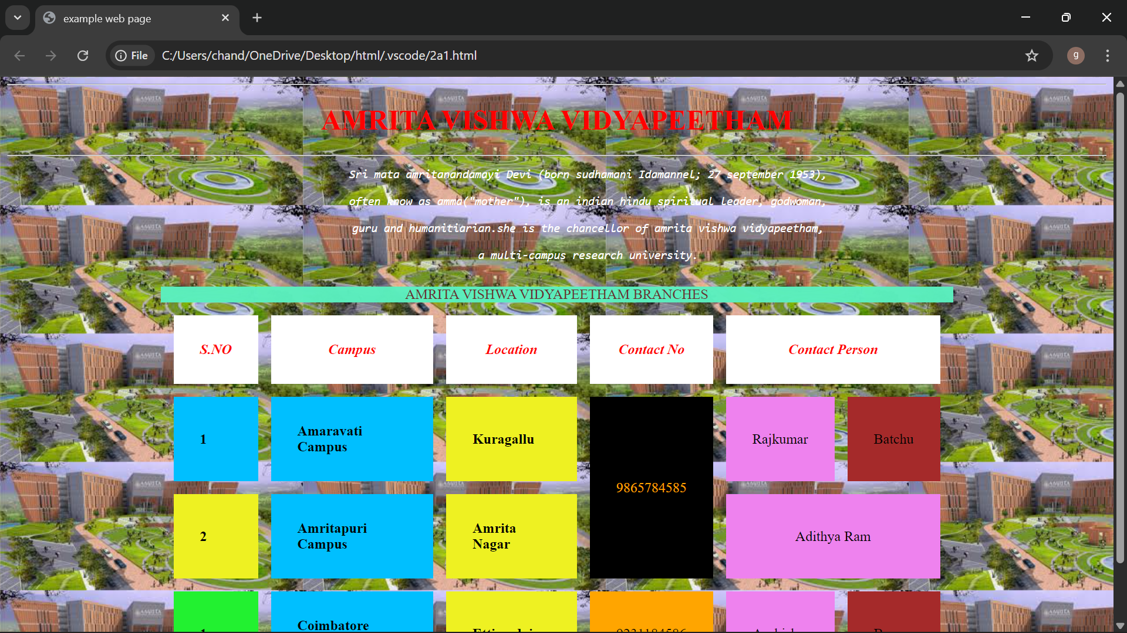

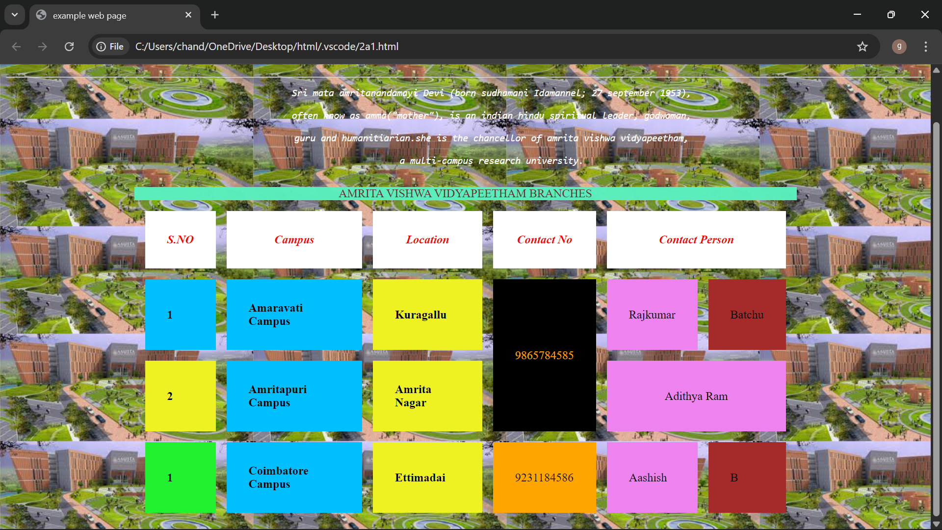

Explanation of the tags:

1.<DOCTYPE html> : the <!DOCTYPE html> element tells the web browser that this an HTML document or this is the latest version of HTML
2.<html> : the <html> element is the root element of an HTML web page
3.<head> : the <head> element will contain meta data about the HTML web page
4.<title> : the <title> element specifies a title for the HTML Page
5.<body> : the <body> element contains all visible content all visible content like text , image , links, tables , etc
6.<table>: the element <table> is used to create a table
7.<tr>: the element <tr> creates a new row in the table
8.<th>: the element <th> create a new heading inside the table
9.<td>: the element <td> fill the columns in the row
10.<button>: the element <button> is used for button .

Week-3
1.Aim:Create class timetable using html elements.
Program:
<!DOCTYPE html>
<html>
<head>CSE-C TIMETABLE</head>
<P>V.GOPAL</P>
<p>AV.SC.U4CSE25249</p>
<p>SEMESTER II</p>
<table border="1">
<tr cell padding="10">
<th>time/day</th>
<th>slot1(8:55-9:45)</th>
<th>slot2(9:45-10:35)</th>
<th>break(10:35-10:45)</th>
<th>slot3(10:45-11:35)</th>
<th>slot4(11:35-12:25)</th>
<th>slot5(12:25-1:15)</th>
<th>lunch break(1:15-2:05)</th>
<th>slot6(2:10-3:00)</th>
<th>break(3:00-3:10)</th>
<th>slot7(3:10-4:00)</th>
<th>slot8(4:00-4:50)</th>
</tr>
<tr cell spacing="10">
<td colspan="1">monday</td>
<td colspan="2">DISCRETE MATHEMATICS</td>
<td colspan="1"> </td>
<td colspan="1">MODERN PHYSICS</td>
<td colspan="1">OOP</td>
<td colspan="1">GLIMPSES OF GLORIOUS INDIA</td>
<td colspan="1"> </td>
<td colspan="1">GLIMPSES OF GLORIOUS INDIA</td>
<td colspan="1"> </td>
<td colspan="2">library/sports</td>
</tr>
<tr cell spacing="10">
<td colspan="1">TUESDAY</td>
<td colspan="2">UID LAB</td>
<td colspan="1"> </td>
<td colspan="1">LINEAR ALGEBRA</td>
<td colspan="1">DISCRETE MATHEMATICS</td>
<td colspan="1">COUNSELLING</td>
<td colspan="1"> </td>
<td colspan="1">manufacturing practice lab</td>
<td colspan="1"> </td>
<td colspan="2">manufacturing practice lab</td>
</tr>
<tr cell spacing="10">
<td colspan="1">wednesday</td>
<td colspan="1">MODERN PYSICS</td>
<td colspan="1">uid</td>
<td colspan="1"> </td>
<td colspan="2">linear algebra</td>
<td colspan="1">counselling</td>
<td colspan="1"> </td>
<td colspan="1">library</td>
<td colspan="1"> </td>
<td colspan="1">glimpses of glorious</td>
<td colspan="1">library/sports</td>
</tr>
<tr cell spacing="10">
<td colspan="1">thursday</td>
<td colspan="1">oop</td>
<td colspan="1">discrete mathematics</td>
<td colspan="1"> </td>
<td colspan="2">oops lab</td>
<td colspan="1">linear algebra</td>
<td colspan="1"> </td>
<td colspan="1">library</td>
<td colspan="1"> </td>
<td colspan="2">library/sports</td>
</tr>
<tr cell spacing="10">
<td colspan="1">friday</td>
<td colspan="1">oop</td>
<td colspan="1">discrete mathematics</td>
<td colspan="1"> </td>
<td colspan="1">modern physics</td>
<td colspan="1">uid</td>
<td colspan="1">linear algebra</td>
<td colspan="1"> </td>
<td colspan="1">library</td>
<td colspan="1"> </td>
<td colspan="2">library/sports</td>
</tr>
</table>
</html>
<p> </p>
<p> </p>
<html>
<p> </p>
<head> theory and lab</head>
<p> </p>
<table border="1">
<tr cell spacing="7">
<td calspan="1">Course Code</td>
<td colspan="1">Course Name</td>
<td colspan="1">L-T-P</td>
<td colspan="1">Credits</td>
<td colspan="2">Faculty Name</td>
<td colspan="2">Assisting Faculty</td>
</tr>
<tr cell spacing="7">
<td calspan="1">23MAT116</td>
<td colspan="1">DISCRETE MATHEMATICS</td>
<td colspan="1">3-0-2</td>
<td colspan="1">4</td>
<td colspan="2">Dr.Srivivasa Rao Thota</td>
<td colspan="2"></td>
</tr>
<tr cell spacing="7">
<td calspan="1">23MAT117</td>
<td colspan="1">Linear Algebra</td>
<td colspan="1">3-0-2</td>
<td colspan="1">4</td>
<td colspan="2">Mr.Sapavat Bixapathi</td>
<td colspan="2"></td>
</tr>
<tr cell spacing="7">
<td calspan="1">23CSE111</td>
<td colspan="1">Object Oriented Programming</td>
<td colspan="1">3-0-2</td>
<td colspan="1">4</td>
<td colspan="2">Dr.SATYA RAJENDRA SINGH R</td>
<td colspan="2">Dr. Balaji TK</td>
</tr>
<tr cell spacing="7">
<td calspan="1">23PHY115</td>
<td colspan="1">Modern Physics</td>
<td colspan="1">2-1-0</td>
<td colspan="1">3</td>
<td colspan="2">Dr.Soumya</td>
<td colspan="2"></td>
</tr>
<tr cell spacing="7">
<td calspan="1">23CSE113</td>
<td colspan="1">User Interface Design</td>
<td colspan="1">2-0-2</td>
<td colspan="1">3</td>
<td colspan="2">Dr.Rajkumar Batchu</td>
<td colspan="2">Mr. Barge Bharadwaj</td>
</tr>
<tr cell spacing="7">
<td calspan="1">23MEE115</td>
<td colspan="1">Manufacturing Practice</td>
<td colspan="1">0-0-3</td>
<td colspan="1">1</td>
<td colspan="2">Dr. Sathies S.</td>
<td colspan="2"></td>
</tr>
<tr cell spacing="7">
<td calspan="1">23ADM111</td>
<td colspan="1">Manufacturing Practice</td>
<td colspan="1">2-0-1</td>
<td colspan="1">1</td>
<td colspan="2">Dr. Sathies S.</td>
<td colspan="2"></td>
</tr>
<tr cell spacing="7">
<td calspan="1"> </td>
<td colspan="1">Total (15L + 1Tut +12P =28 hrs)</td>
<td colspan="1">15-1-12</td>
<td colspan="1">21</td>
<td colspan="2"> </td>
<td colspan="2"> </td>
</tr>
</table>
</html>
<html>

Output:
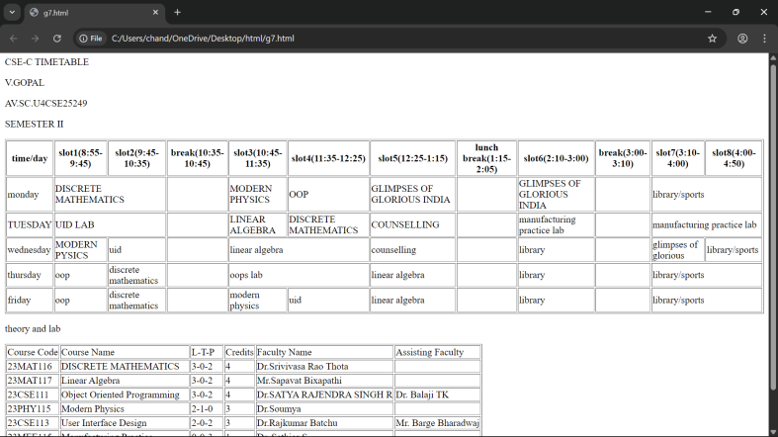
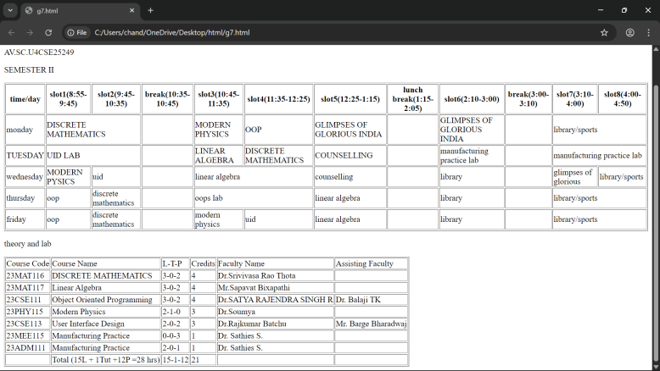

2.Create a html web page that should display syllabus of all the subjects as an image format.
Program:
<!DOCTYPE html>
<html>
<head>CSE-C TIMETABLE</head>
<P>V.GOPAL</P>
<p>AV.SC.U4CSE25249</p>
<p>SEMESTER II</p>
<table border="1">
<tr cell padding="10">
<th>time/day</th>
<th>slot1(8:55-9:45)</th>
<th>slot2(9:45-10:35)</th>
<th>break(10:35-10:45)</th>
<th>slot3(10:45-11:35)</th>
<th>slot4(11:35-12:25)</th>
<th>slot5(12:25-1:15)</th>
<th>lunch break(1:15-2:05)</th>
<th>slot6(2:10-3:00)</th>
<th>break(3:00-3:10)</th>
<th>slot7(3:10-4:00)</th>
<th>slot8(4:00-4:50)</th>
</tr>
<tr cell spacing="10">
<td colspan="1">monday</td>
<td colspan="2">DISCRETE MATHEMATICS</td>
<td colspan="1"> </td>
<td colspan="1">MODERN PHYSICS</td>
<td colspan="1">OOP</td>
<td colspan="1">GLIMPSES OF GLORIOUS INDIA</td>
<td colspan="1"> </td>
<td colspan="1">GLIMPSES OF GLORIOUS INDIA</td>
<td colspan="1"> </td>
<td colspan="2">library/sports</td>
</tr>
<tr cell spacing="10">
<td colspan="1">TUESDAY</td>
<td colspan="2">UID LAB</td>
<td colspan="1"> </td>
<td colspan="1">LINEAR ALGEBRA</td>
<td colspan="1">DISCRETE MATHEMATICS</td>
<td colspan="1">COUNSELLING</td>
<td colspan="1"> </td>
<td colspan="1">manufacturing practice lab</td>
<td colspan="1"> </td>
<td colspan="2">manufacturing practice lab</td>
</tr>
<tr cell spacing="10">
<td colspan="1">wednesday</td>
<td colspan="1">MODERN PYSICS</td>
<td colspan="1">uid</td>
<td colspan="1"> </td>
<td colspan="2">linear algebra</td>
<td colspan="1">counselling</td>
<td colspan="1"> </td>
<td colspan="1">library</td>
<td colspan="1"> </td>
<td colspan="1">glimpses of glorious</td>
<td colspan="1">library/sports</td>
</tr>
<tr cell spacing="10">
<td colspan="1">thursday</td>
<td colspan="1">oop</td>
<td colspan="1">discrete mathematics</td>
<td colspan="1"> </td>
<td colspan="2">oops lab</td>
<td colspan="1">linear algebra</td>
<td colspan="1"> </td>
<td colspan="1">library</td>
<td colspan="1"> </td>
<td colspan="2">library/sports</td>
</tr>
<tr cell spacing="10">
<td colspan="1">friday</td>
<td colspan="1">oop</td>
<td colspan="1">discrete mathematics</td>
<td colspan="1"> </td>
<td colspan="1">modern physics</td>
<td colspan="1">uid</td>
<td colspan="1">linear algebra</td>
<td colspan="1"> </td>
<td colspan="1">library</td>
<td colspan="1"> </td>
<td colspan="2">library/sports</td>
</tr>
</table>
</html>
<p> </p>
<p> </p>
<html>
<p> </p>
<head> theory and lab</head>
<p> </p>
<table border="1">
<tr cell spacing="7">
<td calspan="1">Course Code</td>
<td colspan="1">Course Name</td>
<td colspan="1">L-T-P</td>
<td colspan="1">Credits</td>
<td colspan="2">Faculty Name</td>
<td colspan="2">Assisting Faculty</td>
</tr>
<tr cell spacing="7">
<td calspan="1">23MAT116</td>
<td colspan="1">DISCRETE MATHEMATICS</td>
<td colspan="1">3-0-2</td>
<td colspan="1">4</td>
<td colspan="2">Dr.Srivivasa Rao Thota</td>
<td colspan="2"></td>
</tr>
<tr cell spacing="7">
<td calspan="1">23MAT117</td>
<td colspan="1">Linear Algebra</td>
<td colspan="1">3-0-2</td>
<td colspan="1">4</td>
<td colspan="2">Mr.Sapavat Bixapathi</td>
<td colspan="2"></td>
</tr>
<tr cell spacing="7">
<td calspan="1">23CSE111</td>
<td colspan="1">Object Oriented Programming</td>
<td colspan="1">3-0-2</td>
<td colspan="1">4</td>
<td colspan="2">Dr.SATYA RAJENDRA SINGH R</td>
<td colspan="2">Dr. Balaji TK</td>
</tr>
<tr cell spacing="7">
<td calspan="1">23PHY115</td>
<td colspan="1">Modern Physics</td>
<td colspan="1">2-1-0</td>
<td colspan="1">3</td>
<td colspan="2">Dr.Soumya</td>
<td colspan="2"></td>
</tr>
<tr cell spacing="7">
<td calspan="1">23CSE113</td>
<td colspan="1">User Interface Design</td>
<td colspan="1">2-0-2</td>
<td colspan="1">3</td>
<td colspan="2">Dr.Rajkumar Batchu</td>
<td colspan="2">Mr. Barge Bharadwaj</td>
</tr>
<tr cell spacing="7">
<td calspan="1">23MEE115</td>
<td colspan="1">Manufacturing Practice</td>
<td colspan="1">0-0-3</td>
<td colspan="1">1</td>
<td colspan="2">Dr. Sathies S.</td>
<td colspan="2"></td>
</tr>
<tr cell spacing="7">
<td calspan="1">23ADM111</td>
<td colspan="1">Manufacturing Practice</td>
<td colspan="1">2-0-1</td>
<td colspan="1">1</td>
<td colspan="2">Dr. Sathies S.</td>
<td colspan="2"></td>
</tr>
<tr cell spacing="7">
<td calspan="1"> </td>
<td colspan="1">Total (15L + 1Tut +12P =28 hrs)</td>
<td colspan="1">15-1-12</td>
<td colspan="1">21</td>
<td colspan="2"> </td>
<td colspan="2"> </td>
</tr>
</table>
</html>
<html>
<body>
<p style="background-color: yellow;">Discrete Mathematics</p>
<img src=C:\Users\chand\OneDrive\Pictures\Screenshots\dicrete.png>
<p style="background-color: yellow;">Linear Algebra</p>
<img src=C:\Users\chand\OneDrive\Pictures\Screenshots\linear.png>
<p style="background-color: yellow;">object oriented programing</p>
<img src=C:\Users\chand\OneDrive\Pictures\Screenshots\oops.png>
<p style="background-color: yellow;">Modren Physics</p>
<img src=C:\Users\chand\OneDrive\Pictures\Screenshots\modern.png>
<p style="background-color: yellow;">UI Design</p>
<img src=C:\Users\chand\OneDrive\Pictures\Screenshots\uidsrc.png>
<p style="background-color: yellow;">Manufacturing Practice</p>
<img src=C:\Users\chand\OneDrive\Pictures\Screenshots\manu.png>
<p style="background-color: yellow;">GGI</p>
<img src=C:\Users\chand\OneDrive\Pictures\Screenshots\ggi.png>
</body>
</html>

Output:
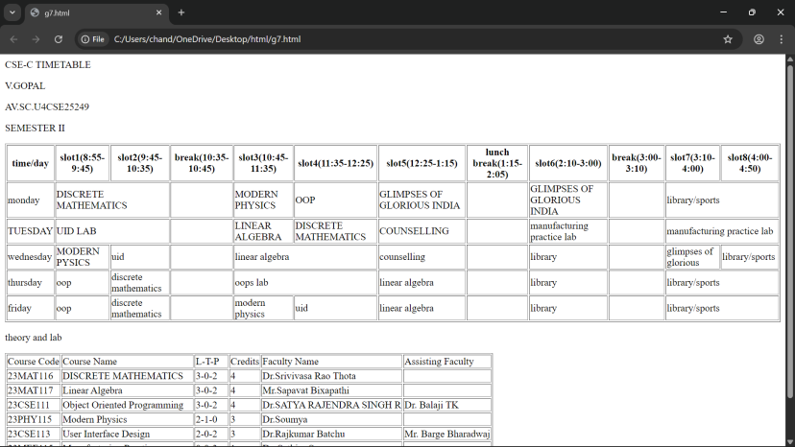
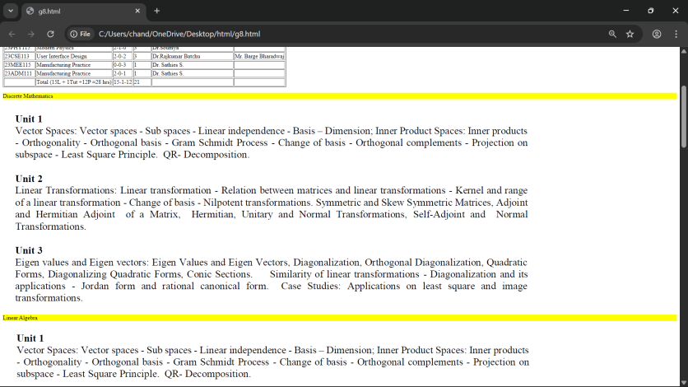
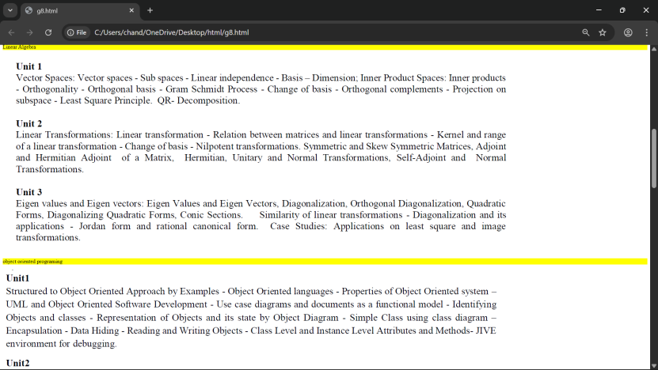
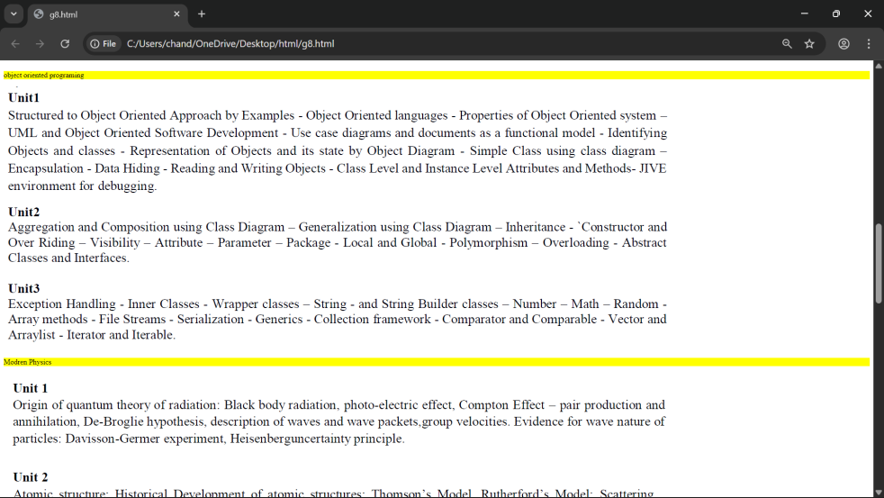
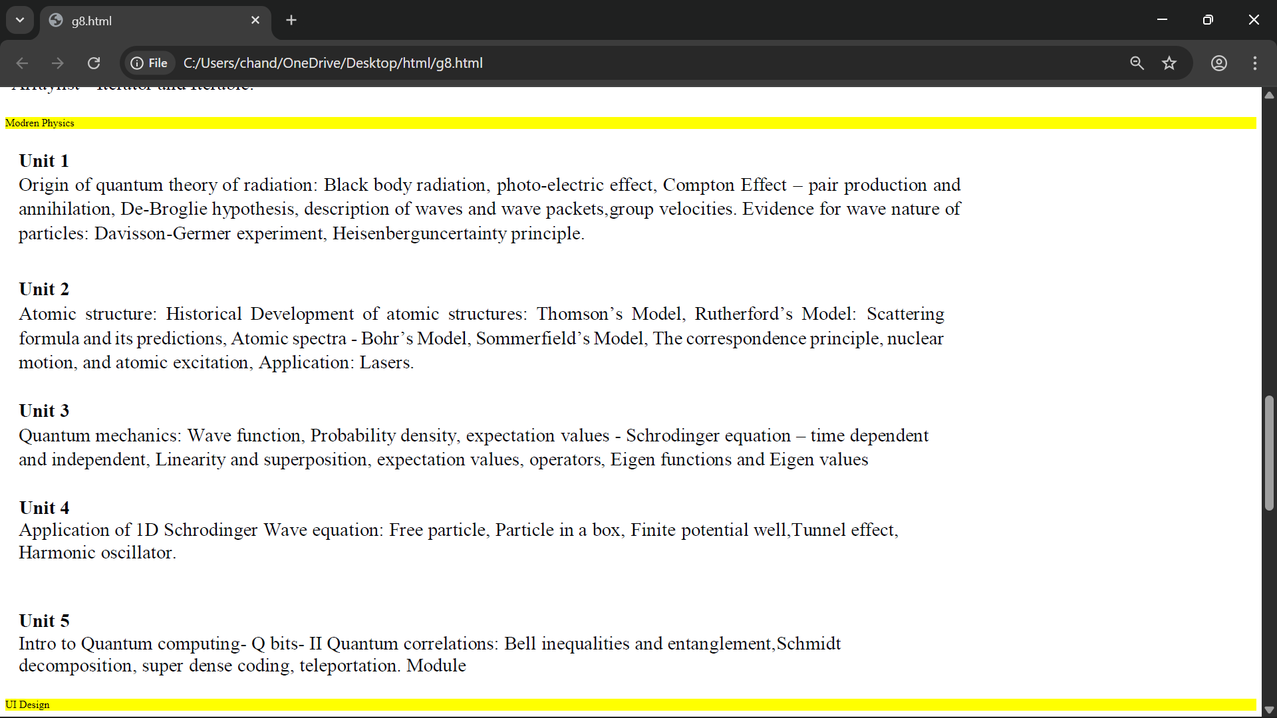
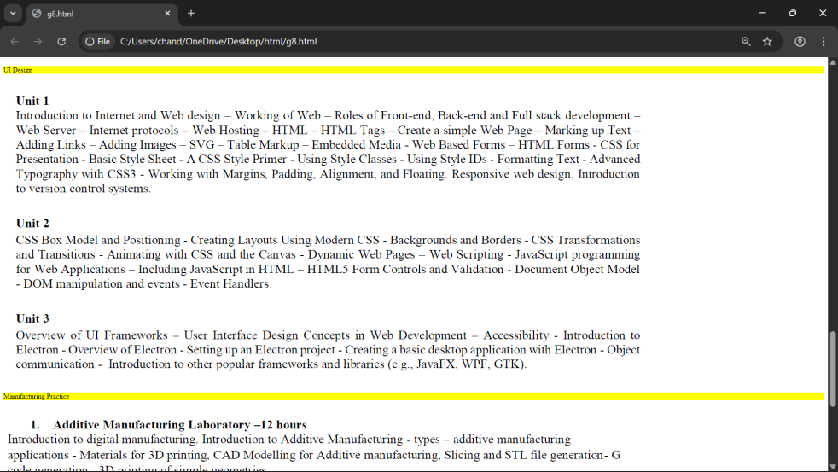

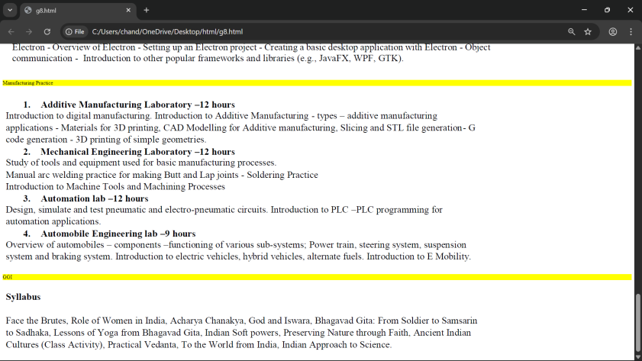
Explanation of the tags:
- <table>: the <table> tag is used to arrange data into rows and columns.
- <tr>: Creates a horizontal row.
- <th>: Defines a header cell (usually bold and centred by default).
- <td>: <td> tag stands for table Data.
- colspan attribute: It is used to merge multiple columns across horizontally.
- rowspan attribute: It is used to merge multiple rows across vertically.
- <b>: It makes text bold.
- <br>: It breaks the line and move to next line.
- <img>: It is used to insert images.

WEEK-4
a)Aim: Design a registration form using only HTML tags (no CSS) with proper labels, table
alignment, background color, and borders.
Program:
UID-AV.SC.U4CSE25249
<!DOCTYPE html>
<html>
<head>
<title>College Admission Registration</title>
</head>
<body bgcolor="#e6e6fa">
<center>
<h2>College Admission Registration</h2>
<table border="2" cellpadding="8" cellspacing="0" bgcolor="yellow">
<tr>
<td><label for="name">Full Name:</label></td>
<td><input type="text" id="name" name="name" size="40"></td>
</tr>
<tr>
<td><label for="email">Email:</label></td>
<td><input type="email" id="email" name="email" size="40"></td>
</tr>
<tr>
<td><label for="phone">Phone Number:</label></td>
<td><input type="tel" id="phone" name="phone" size="40"></td>
</tr>
<tr>
<td>Gender:</td>
<td>
<input type="radio" name="gender" value="male"> Male
<input type="radio" name="gender" value="female"> Female
<input type="radio" name="gender" value="other"> Other
</td>
</tr>
<tr>
<td><label for="course">Course Applying For:</label></td>
<td>
<select id="course" name="course">
<option>B.Tech</option>
<option>B.Sc</option>
<option>B.Com</option>
<option>BA</option>
</select>
</td>
</tr>
<tr>
<td>Hobbies:</td>
<td>
<input type="checkbox" name="hobby" value="sports"> Sports
<input type="checkbox" name="hobby" value="music"> Music
<input type="checkbox" name="hobby" value="reading"> Reading
</td>
</tr>
<tr>
<td><label for="dob">Date of Birth:</label></td>
<td><input type="date" id="dob" name="dob"></td>
</tr>
<tr>
<td><label for="file">Upload Certificates:</label></td>
<td><input type="file" id="file" name="file"></td>
</tr>
<tr>
<td><label for="address">Address:</label></td>
<td>
<textarea id="address" name="address" rows="4"
cols="35"></textarea>
</td>
</tr>
<tr align="center">
<td colspan="2">
<input type="submit" value="Submit">
<input type="reset" value="Reset">
</td>
</tr>
</table>
</center>
</body>
</html>

Output:
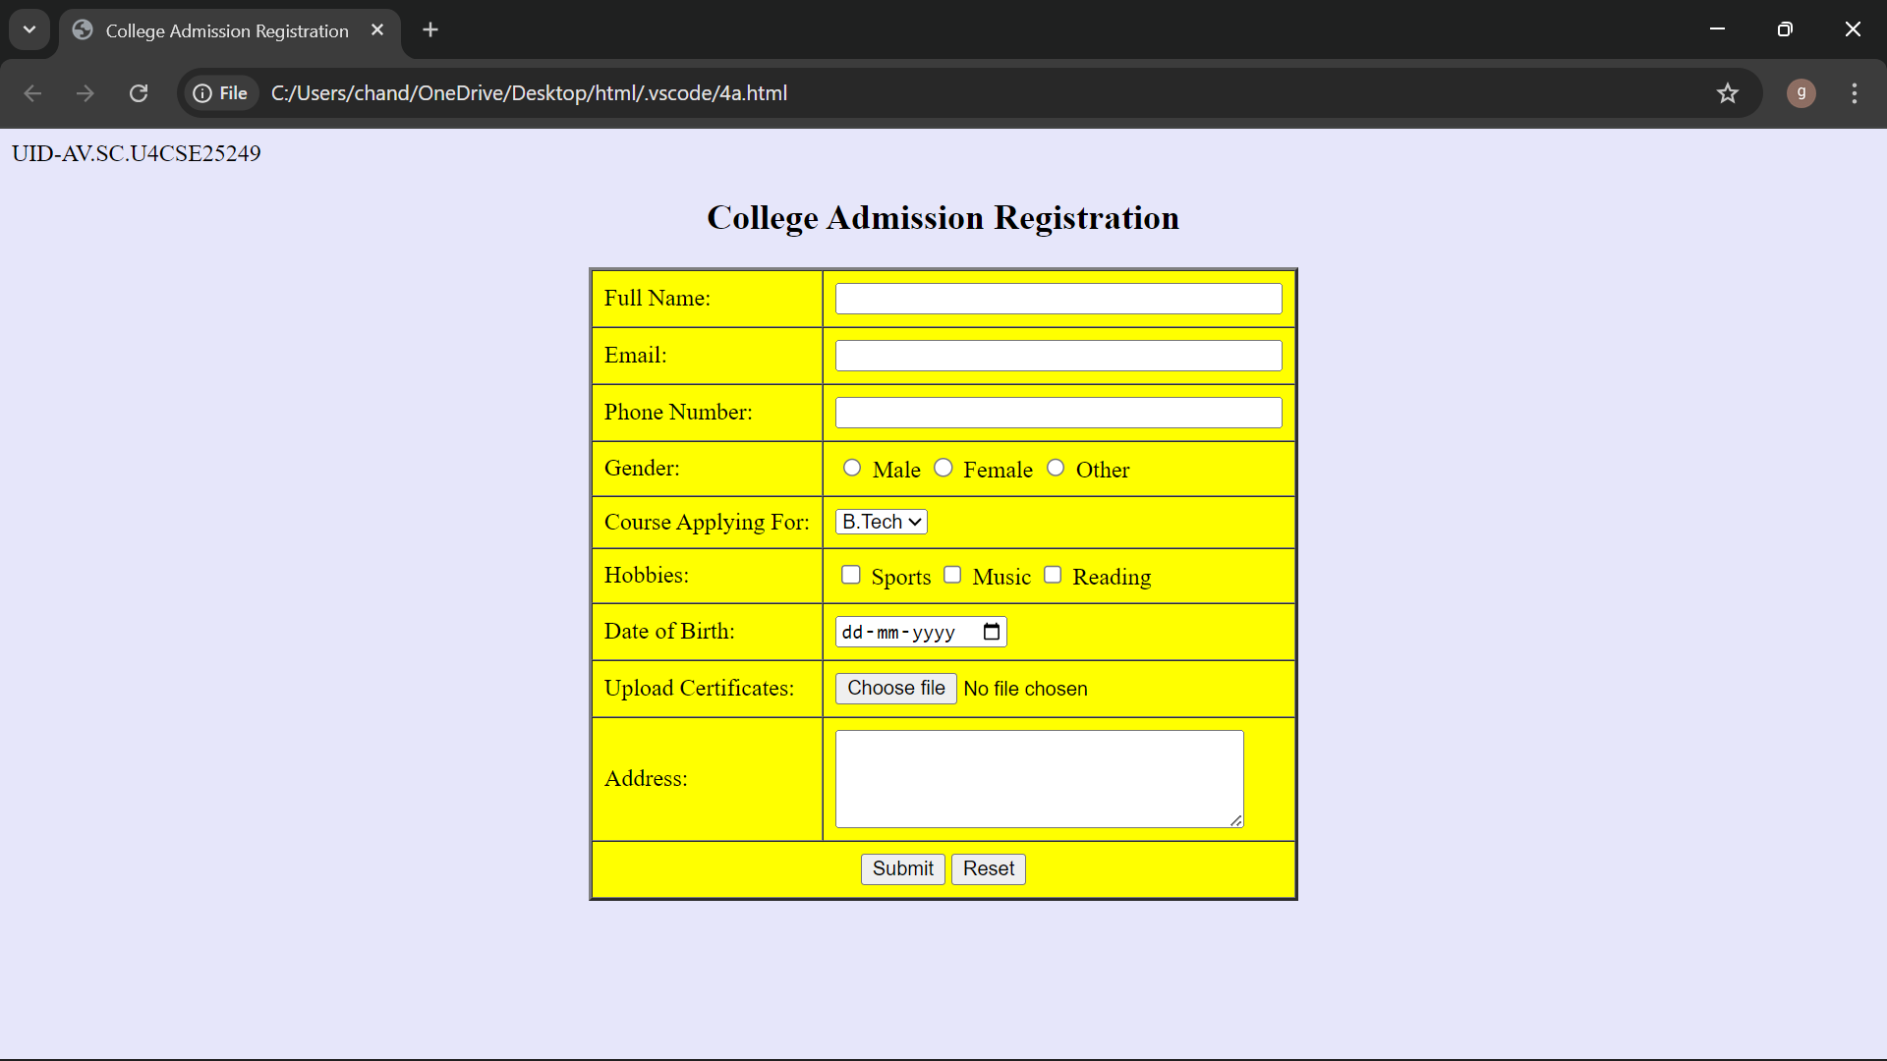

Explanation of the tags:
1.<DOCTYPE html> : <!DOCTYPE html> element tells the web browser that this an HTML document
or this is the latest version of HTML
2.<html> : the <html> element is the root element of an HTML web page
3.<head> : the <head> element will contain meta data about the HTML web page
4.<title> : the <title> element specifies a title for the HTML Page
5.<body> : the <body> element contains all visible content all visible content like text , image , links ,
tables , etc
6.<h> : we used <h> element for heading
7.<p> : we used <p> element for the paragraph
8.<table>: the element <table> is used to create a table
9.<tr>: the element <tr> creates a new row in the table
10.<th>: the element <th> create a new heading inside the table
11.<td>: the element <td> fill the columns in the row
12.<label>:we used <label> element for linking the input to specific id name and we use for attribute for it
13.<input>:we use <input> element for the input elements in the forms
14.<select>:we use <select> element for creation of drop box
15.<option>:we use <option> element for creating the options in the drop box
- Aim: Design two different forms in one webpage using Iframes.
Program:
UID-AV.SC.U4CSE25249
<!DOCTYPE html>
<html>
<head>
<title>Two Forms Using Iframes</title>
</head>
<body bgcolor="#e6e6cc">
<h2 align="center">Two Forms Displayed Using Iframes</h2>
<table align="center" cellpadding="20">
<tr>
<td>
<iframe src="login.html" width="350" height="300"></iframe>
</td>
<td>
<iframe src="register.html" width="350" height="300"></iframe>
</td>
</tr>
</table>
</body>
</html>
Login.html:
UID-AV.SC.U4CSE25249
<!DOCTYPE html>
<html>
<head>
<title>Login Form</title>
</head>
<body>
<h3 align="center">User Login</h3>
<form>
<table border="1" align="center" cellpadding="8">
<tr>
<td><label for="username">Username:</label></td>
<td><input type="text" id="username" name="username"></td>
</tr>
<tr>
<td><label for="password">Password:</label></td>
<td><input type="password" id="password" name="password"></td>
</tr>
<tr align="center">
<td colspan="2">
<input type="submit" value="Login">
</td>
</tr>
</table>
</form>
</body>
</html>
Register.html:
UID-AV.SC.U4CSE25249
<!DOCTYPE html>
<html>
<head>
<title>Registration Form</title>
</head>
<body>
<h3 align="center">User Registration</h3>
<form>
<table border="1" align="center" cellpadding="8">
<tr>
<td><label for="name">Full Name:</label></td>
<td><input type="text" id="name" name="name"></td>
</tr>
<tr>
<td><label for="email">Email:</label></td>
<td><input type="email" id="email" name="email"></td>
</tr>
<tr>
<td><label for="phone">Phone:</label></td>
<td><input type="tel" id="phone" name="phone"></td>
</tr>
<tr>
<td>Password:</td>
<td><input type="password" name="password"></td>
</tr>
<tr align="center">
<td colspan="2">
<input type="submit" value="Register">
<input type="reset" value="Reset">
</td>
</tr>
</table>
</form>
</body>
</html>
Output:
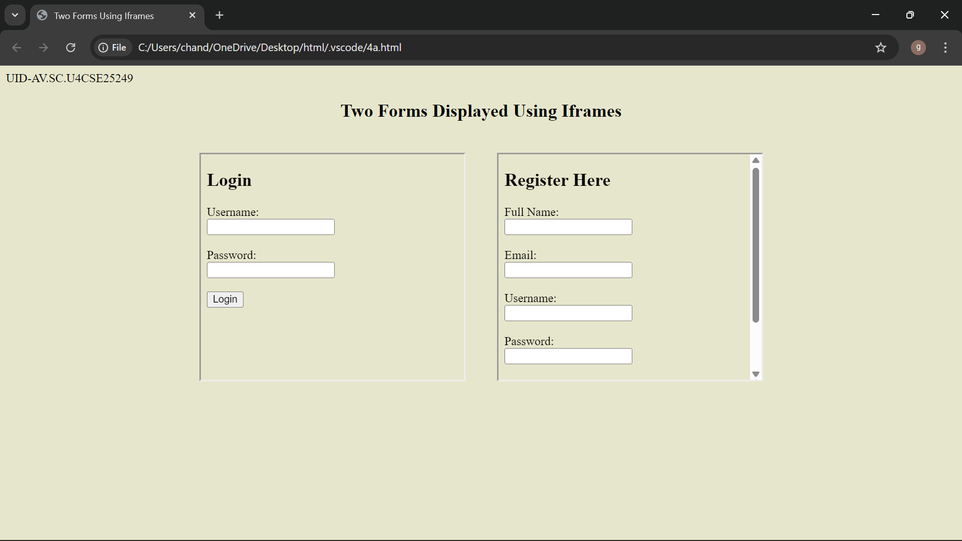
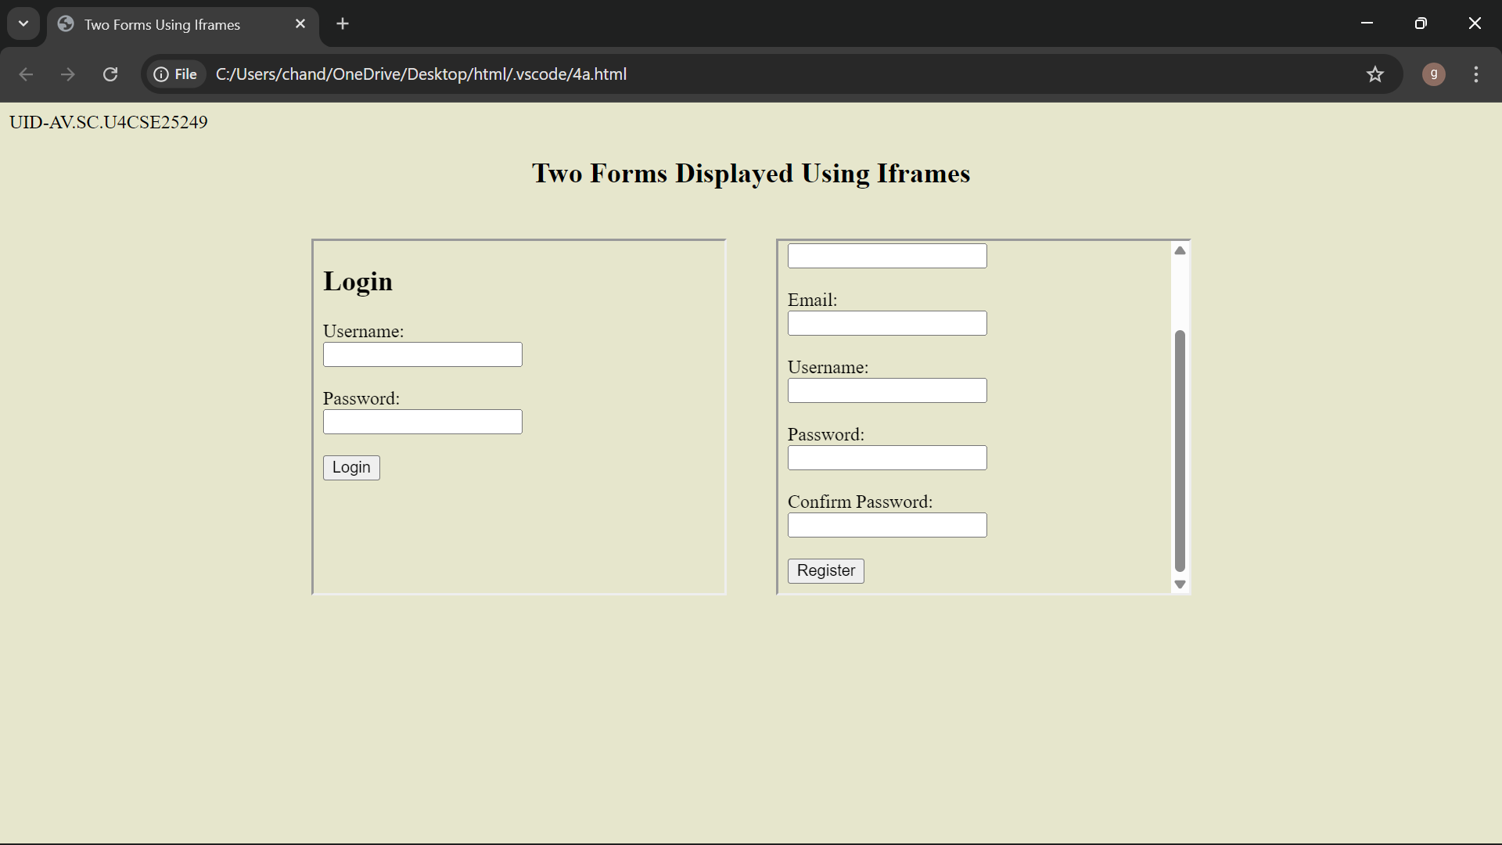

Explanation of the tags:
<DOCTYPE html> : the <!DOCTYPE html> element tells the web browser that this an HTML document
or this is the latest version of HTML
<html> : the <html> element is the root element of an HTML web page
<head> : the <head> element will contain meta data about the HTML web page
<title> : the <title> element specifies a title for the HTML Page
<body> : the <body> element contains all visible content all visible content like text , image , links ,
tables , etc
<h> : we used <h> element for heading
<p> : we used <p> element for the paragraph
<table>: the element <table> is used to create a table
<tr>: the element <tr> creates a new row in the table
<th>: the element <th> create a new heading inside the table
<td>: the element <td> fill the columns in the row
<label>:we used <label> element for linking the input to specific id name and we use for attribute for it
<input>:we use <input> element for the input elements in the forms
<select>:we use <select> element for creation of drop box
<option>:we use <option> element for creating the options in the drop box
<iframes>:we use <iframes> element for adding anoter html file to main html file

WEEK-5
a) Aim: creating a card layout using <div> tag consider three cards and a button using html and css
Program:
UID-AV.SC.U4CSE25249
<!DOCTYPE html>
<html>
<head>
<title>the Big three</title>
<style> body{
font-family:Arial;
background:#050c1e;
text-align:center;
}
h1{
background:#fff200 ;
padding:20px;
}
.container{
display:flex; flex-wrap:wrap;
justify-content:center; gap:20px;
padding:30px;
}
.card{
background:white; color:black; width:260px; padding:20px; border-radius:12px;
box-shadow:0 5px 15px gray;
}
.god-img{
width:150px; height:200px; object-fit:cover; border-radius:8px;
}
button{
padding:8px 16px; border:none; background:#b91c1c; color:white;
border-radius:6px;
}
button:hover{
background:black;
}
</style>
</head>
<body>
<h1>The Almighty</h1>
<div class="container">
<div class="card">
<img class="god-img" src="C:\Users\chand\Downloads\shiva.jpeg">
<h3>Mahadev</h3>
<p>The God of Distruction</p>
<button>Know More</button>
</div>
<div class="card">
<img class="god-img" src="C:\Users\chand\Downloads\vishnu.jpg">
<h3>Maha Vishnu</h3>
<p>The Protector</p>
<button>Know More</button>
</div>
<div class="card">
<img class="god-img" src="C:\Users\chand\Downloads\bramha.jpg">
<h3>Bramhadev</h3>
<p>The Creater</p>
<button>Know More</button>
</div>
</div>
</body>
</html>
Output:
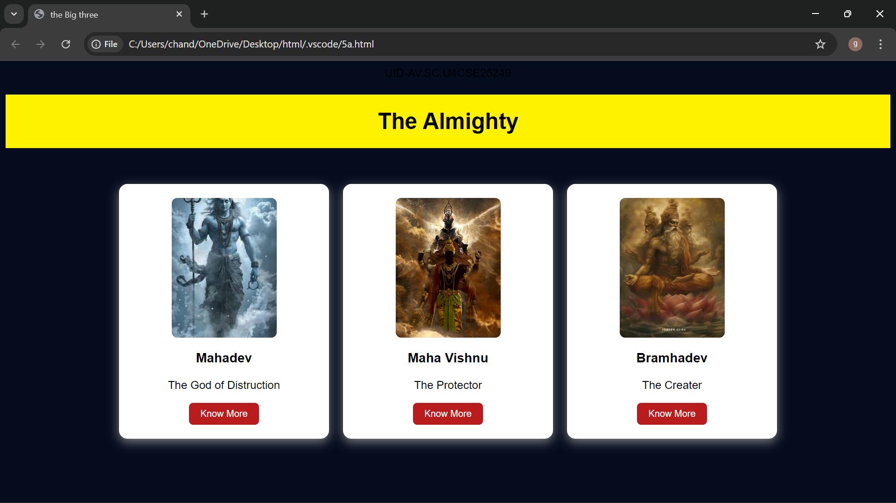

Explanation of the tags:
<DOCTYPE html> : the <!DOCTYPE html> element tells the web browser that this an HTML document or this is the latest version of HTML
<html> : the <html> element is the root element of an HTML web page
<head> : the <head> element will contain meta data about the HTML web page
<title> : the <title> element specifies a title for the HTML Page
<body> : the <body> element contains all visible content all visible content like text , image , links , tables , etc
<h> : we used <h> element for heading
<p> : we used <p> element for the paragraph
<div>:we use <div> element for encapsulating the the divisions and easy to modify and
<button>: we use <button> element for button
<img>: we use <img> tag for displaying the image
b)Aim: Navigation using iframe (mini website) upon clicking each buttons the details about that
button should be display on the same page .
Program:
Superman:
UID-AV.SC.U4CSE25226
<!DOCTYPE html>
<html>
<head>
<title>Superman</title>
<style>
body{margin:0;font-family:Arial;background-color: gray;}
.menu{ background:#580d0d; padding:15px;
text-align:center;
}
.menu a{ color:white; margin:0 15px;
text-decoration:none; background:rgb(44, 42, 42); padding:8px 12px;
}
iframe{ width:100%; height:400px; border:none;
}
</style>
</head>
<body>
<h1 style="text-align:center;background:#b91c1c;color:white;padding:20px;">Iron Man</h1>
<div class="menu">
<a href="strengths.html" target="frame">Strengths & Weaknesses</a>
<a href="personal info.html" target="frame">Personal Info</a>
<a href="contribution.html" target="frame">Contributions</a>
</div>
<iframe name="frame"></iframe>
</body>
</html>

strengths.html:
UID-AV.SC.U4CSE25249
<!DOCTYPE html>
<html>
<head>
<style>
body{font-family:Arial;text-align:center;}
.box{
border:2px solid black;
padding:20px;
display:inline-block;}
h2{color:#b91c1c;}
</style>
</head>
<body>
<div class="box">
<h2>Strengths and Weaknesses</h2>
<p>Strengths: Unmatched strength and speed.</p>
<p>Weaknesses: soft hearted,kryptonite.</p>
<img src="C:\Users\chand\Downloads\superman.jpeg" alt="Superman" style="width:200px;height:200px;">
</div>
</body>
</html>
Personal info.html:
UID-AV.SC.U4CSE25249
<!DOCTYPE html>
<html>
<head>
<style>
body{font-family:Arial;text-align:center}
.box{
border:2px solid black;
padding:20px;
display:inline-block;}
h2{color:#b91c1c;}
</style>
</head>
<body>
<div class="box">
<h2>Personal Information</h2>
<p>Name: Kal el</p>
<p>Job: Journalist</p>
<p>Team: Justicel League</p>
<img src="C:\Users\chand\Downloads\saviour.jpeg" alt="Superman" style="width:200px;margin-top:20px;">
</div>
</html>
Contribution.html
UID-AV.SC.U4CSE25249
<!DOCTYPE html>
<html>
<head>
<style>
body{font-family:Arial;text-align:center}
.box{
border:2px solid rgb(42, 40, 40);
padding:20px;
display:inline-block;}
h2{color:#5c1111;}
</style>
</head>
<body>
<div class="box">
<h2>Contributions</h2>
<p>Saved earth from Zor</p>
<p>defeated Stephenwolf and Darksied.</p>
<p>Saved Earth many times.</p>
<img src="C:\Users\chand\Downloads\stephenwolf.jpg" alt="Superman" style="width:200px;margin-top:20px;">
</div>
</body>
</html>

Output:
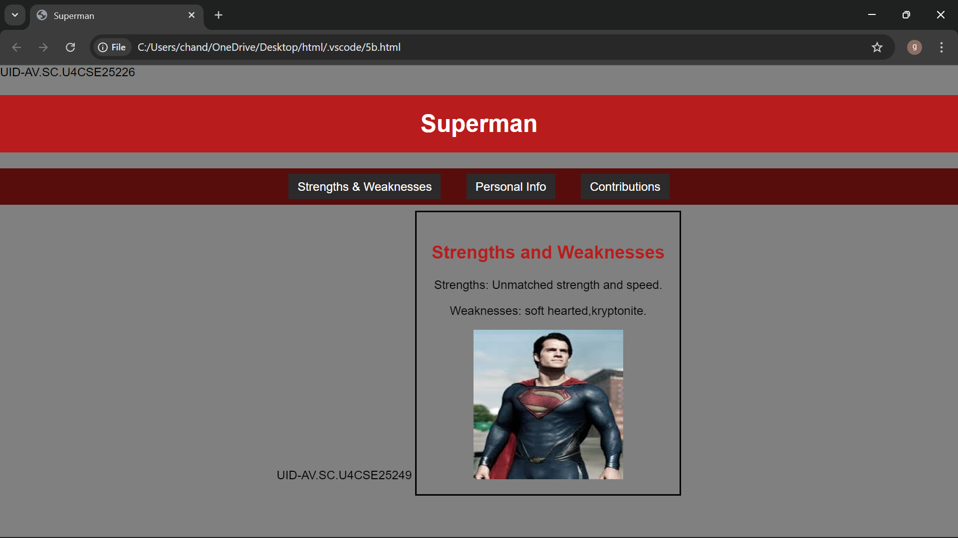

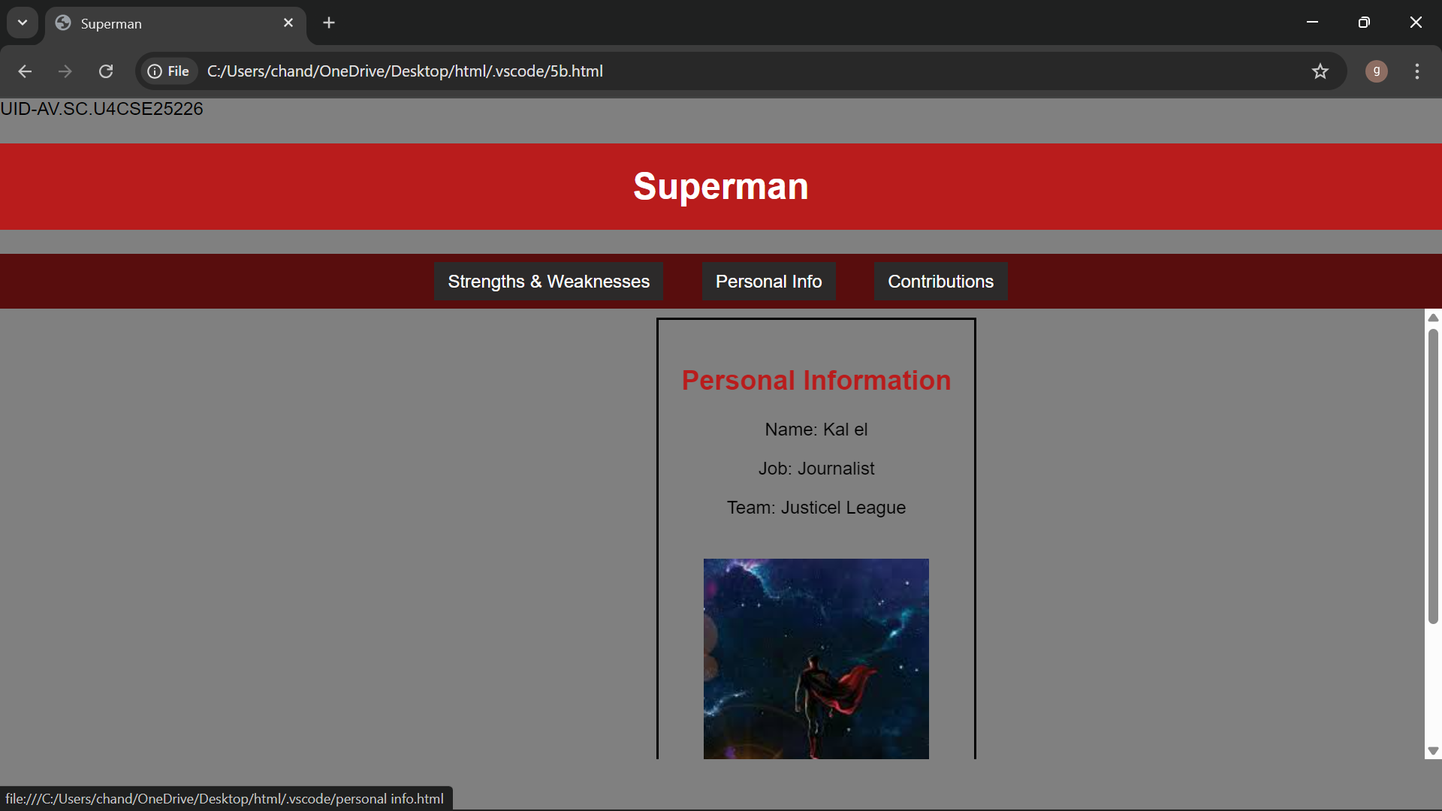

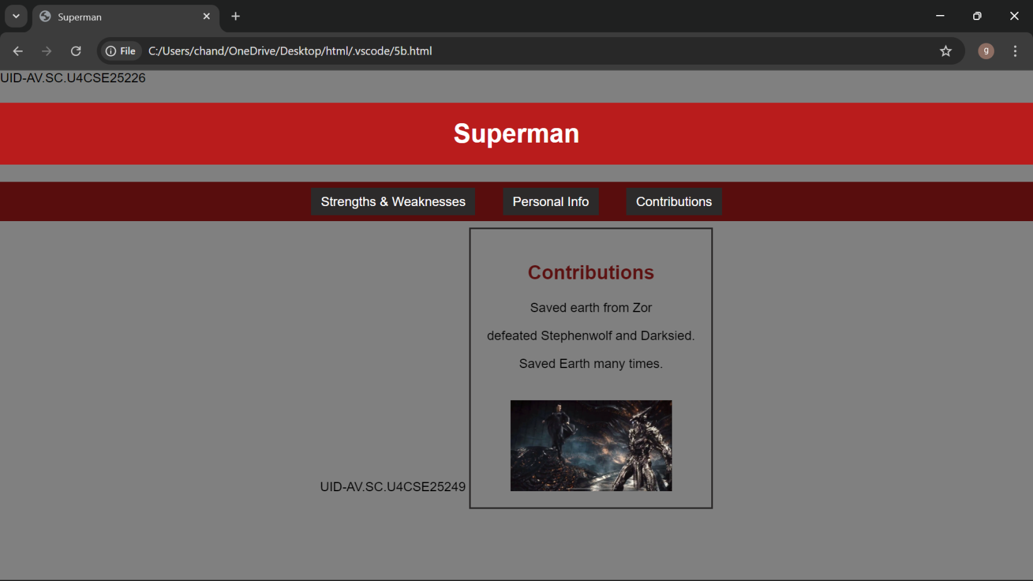

Explanation of the tags:
<DOCTYPE html> : the <!DOCTYPE html> element tells the web browser that this an HTML document or this is the latest version of HTML
<html> : the <html> element is the root element of an HTML web page
<head> : the <head> element will contain meta data about the HTML web page
<title> : the <title> element specifies a title for the HTML Page
<body> : the <body> element contains all visible content all visible content like text , image , links , tables , etc
<h> : we used <h> element for heading
<p> : we used <p> element for the paragraph
<div>:we use <div> element for encapsulating the the divisions and easy to modify and
<button>: we use <button> element for button
<img>: we use <img> tag for displaying the image

c)Aim: Design amrita login page by showcampus on home page.upon clicking on each campus the details about each campus should be display on the same page use html and css to design a stylish webpage
Program:
Webpage:
<!DOCTYPE html>
<html>
<head>
<title>Amrita Vishwa Vidhyapeetam</title>
<style>
body{margin:0;font-family:Arial;background:rgb(101, 101, 139);} header{background:#a00000;color:#fff;text-align:center;
padding:20px;font-size:36px;} nav{background:#0b5ea6;text-align:center;padding:10px;} nav a{color:yellow;margin:12px;text-decoration:none;
font-weight:bold;padding:5px;}
nav a:hover{background:#fff;color:#0b5ea6; border-radius:5px;}
main{display:flex;padding:20px;}
.login{
width:350px; background:#2ecc71; padding:15px; border-radius:10px; color:white;
}
.login input[type="email"],
.login input[type="password"]{ width:90%;
padding:6px; margin:6px 0;
}
.remember{display:flex;align-items:center;gap:6px;margin:8px 0;} iframe{
flex:1;
margin-left:20px; height:520px; border:none; background:lightskyblue; border-radius:10px;
}
</style>
</head>
<body>
<header>AMRITA VISHWA VIDHYAPEETAM</header>
<nav>
<a href="amaravati.html" target="campus">AMARAVATI</a>
<a href="amritapuri.html" target="campus">AMRITAPURI</a>
<a href="bengaluru.html" target="campus">BENGALURU</a>
<a href="chennai.html" target="campus">CHENNAI</a>
<a href="coimbatore.html" target="campus">COIMBATORE</a>
<a href="faridabad.html" target="campus">FARIDABAD</a>
<a href="kochi.html" target="campus">KOCHI</a>
<a href="mysuru.html" target="campus">MYSURU</a>
</nav>
<main>
<div class="login">
<h2>Login</h2> Email
<input type="email"> Password
<input type="password">
<div class="remember">
<input type="checkbox"><label>Save me</label>
</div>
<input type="button" value="Login" style="width:100%;padding:6px;">
<br><br>
<a href="#">Forgot Password?</a><br> No account? <a href="#">Register</a>
</div>
<iframe name="campus" src="amaravati.html"></iframe>
</main>
</body>
</html>

Amaravati:

<!DOCTYPE html>
<html>
<body style="font-family:Arial; text-align:center; padding:30px;">
<h1 style="color:#a00000;">Amaravati Campus</h1>
<p>
Amrita Amaravati campus is located near the Krishna River in Andhra Pradesh. It provides modern classrooms, research labs, and excellent hostel facilities.
</p>
<p>
Popular Courses: CSE, AI, Data Science<br> Facilities: Library, Smart Classrooms, Hostel<br> Focus: Innovation and Research
</p>
<img src="C:\Users\chand\Downloads\amrita amaravati.jpeg" width="450">
</body>
</html>

Amritapuri:

<!DOCTYPE html>
<html>
<body style="font-family:Arial;text-align:center;padding:30px;">
<h1 style="color:#a00000;">Amritapuri Campus</h1>
<p>
Amritapuri campus in Kerala is the main campus of Amrita University, located near the Arabian Sea with a peaceful academic atmosphere.
</p>
<p>
Popular Courses: Engineering, Arts, Sciences<br> Facilities: Research Labs, Beach Campus, Hostel<br> Focus: Academic Excellence with Values
</p>
<img src="C:\Users\chand\Downloads\amrita amritapuri.jpeg" width="450">
</body>
</html>

Banglore:

<!DOCTYPE html>
<html>
<body style="font-family:Arial;text-align:center;padding:30px;">
<h1 style="color:#a00000;">Bengaluru Campus</h1>
<p>
Located in India's tech hub, Bengaluru campus offers advanced engineering programs with strong industry connections.
</p>
<p>
Popular Courses: Robotics, CSE, ECE<br> Facilities: Coding Labs, Innovation Centres<br> Focus: Industry Collaboration
</p>
<img src="C:\Users\chand\Downloads\amrita banglore.jpg" width="450">
</body>
</html>

Chennai:

<!DOCTYPE html>
<html>
<body style="font-family:Arial;text-align:center;padding:30px;">
<h1 style="color:#a00000;">Chennai Campus</h1>
<p>
Chennai campus provides top-quality computing and management education with modern infrastructure and placement support.
</p>
<p>
Popular Courses: IT, MBA, Electronics<br> Facilities: Digital Library, Placement Cell<br> Focus: Career Development
</p>
<img src="C:\Users\chand\Downloads\amrita chennai.jpeg" width="450">
</body>
</html>
Coimbatore:

<!DOCTYPE html>
<html>
<body style="font-family:Arial;text-align:center;padding:30px;">
<h1 style="color:#a00000;">Coimbatore Campus</h1>
<p>
Coimbatore campus is well known for its engineering excellence and research-oriented education.
</p>
<p>
Popular Courses: Mechanical, Civil, CSE<br> Facilities: Workshops, Labs, Hostel<br> Focus: Core Engineering Skills
</p>
<img src="C:\Users\chand\Downloads\amrita coimbatore.jpeg" width="450">
</body>
</html>

Faridabad:

<!DOCTYPE html>
<html>
<body style="font-family:Arial;text-align:center;padding:30px;">
<h1 style="color:#a00000;">Faridabad Campus</h1>
<p>
Faridabad campus focuses on medical and healthcare education with advanced hospital training facilities.
</p>
<p>
Popular Courses: Medical, Nursing, Allied Health<br> Facilities: Teaching Hospital, Labs<br>
Focus: Healthcare Research
</p>
<img src="C:\Users\chand\Downloads\amrita faridabad.jpg" width="450">
</body>
</html>

Kochi:

<!DOCTYPE html>
<html>
<body style="font-family:Arial;text-align:center;padding:30px;">
<h1 style="color:#a00000;">Kochi Campus</h1>
<p>
Kochi campus offers programs in business, commerce, and applied sciences with modern facilities.
</p>
<p>
Popular Courses: MBA, Commerce, Finance<br> Facilities: Seminar Halls, Library<br> Focus: Industry Training
</p>
<img src="C:\Users\chand\Downloads\amrita kochi.jpeg" width="450">
</body>
</html>

Mysore:

<!DOCTYPE html>
<html>
<body style="font-family:Arial;text-align:center;padding:30px;">
<h1 style="color:#a00000;">Mysuru Campus</h1>
<p>
Mysuru campus is known for its peaceful environment, green campus, and quality education.
</p>
<p>
Popular Courses: Arts, Sciences, Engineering<br> Facilities: Hostel, Library, Sports Complex<br> Focus: Calm Learning Atmosphere
</p>
<img src="C:\Users\chand\Downloads\amrita mysore.jpeg" width="450">
</body>
</html>

Output:

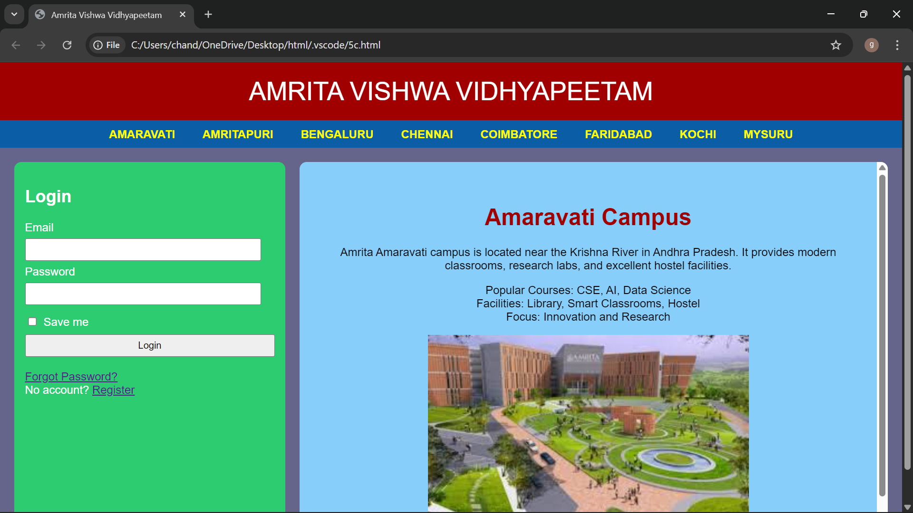

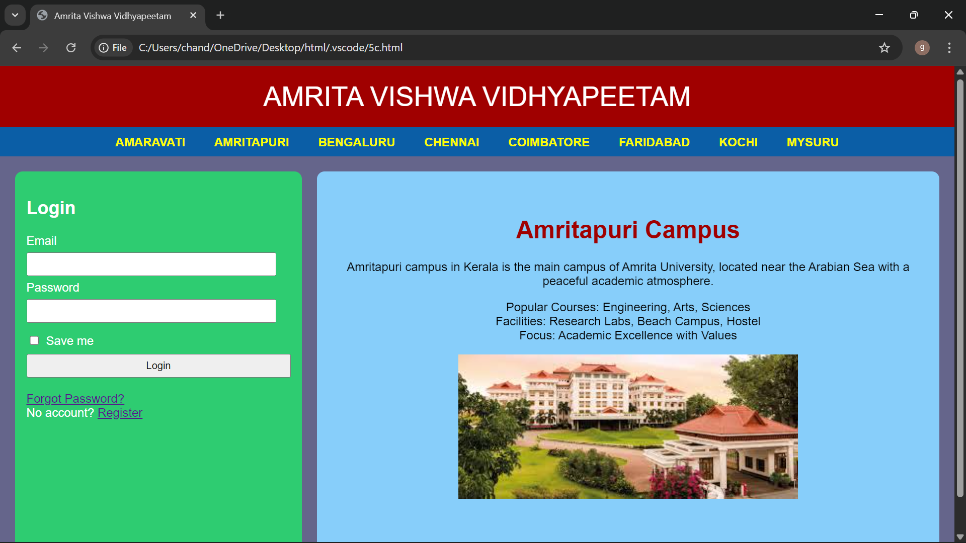

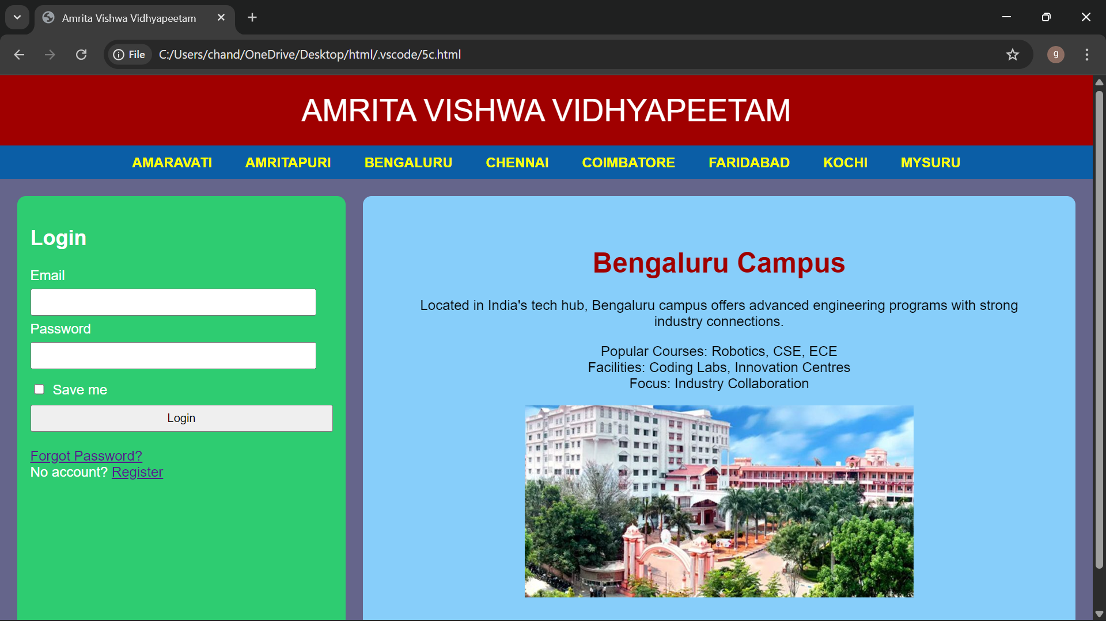

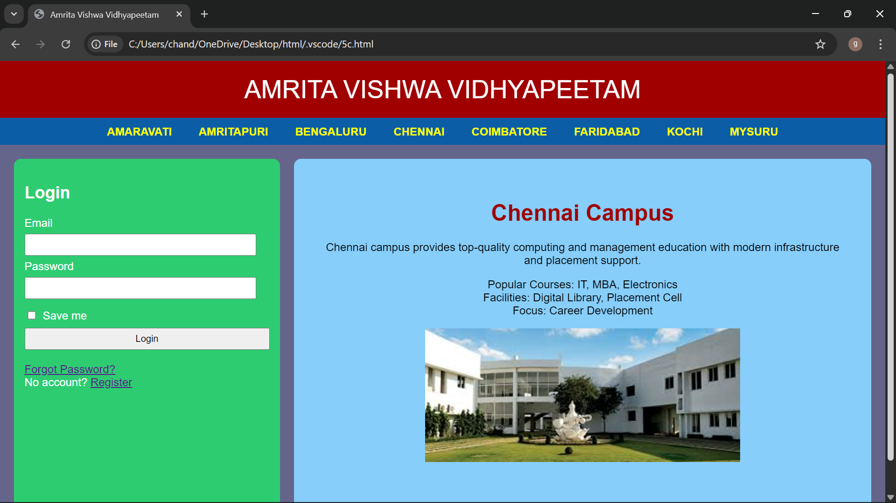

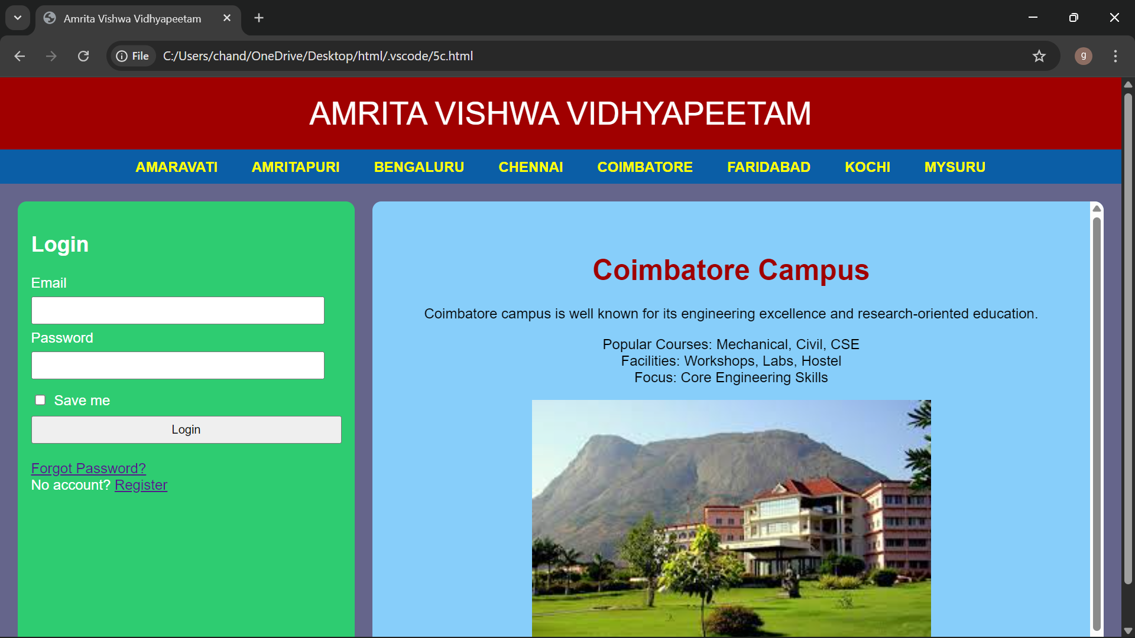

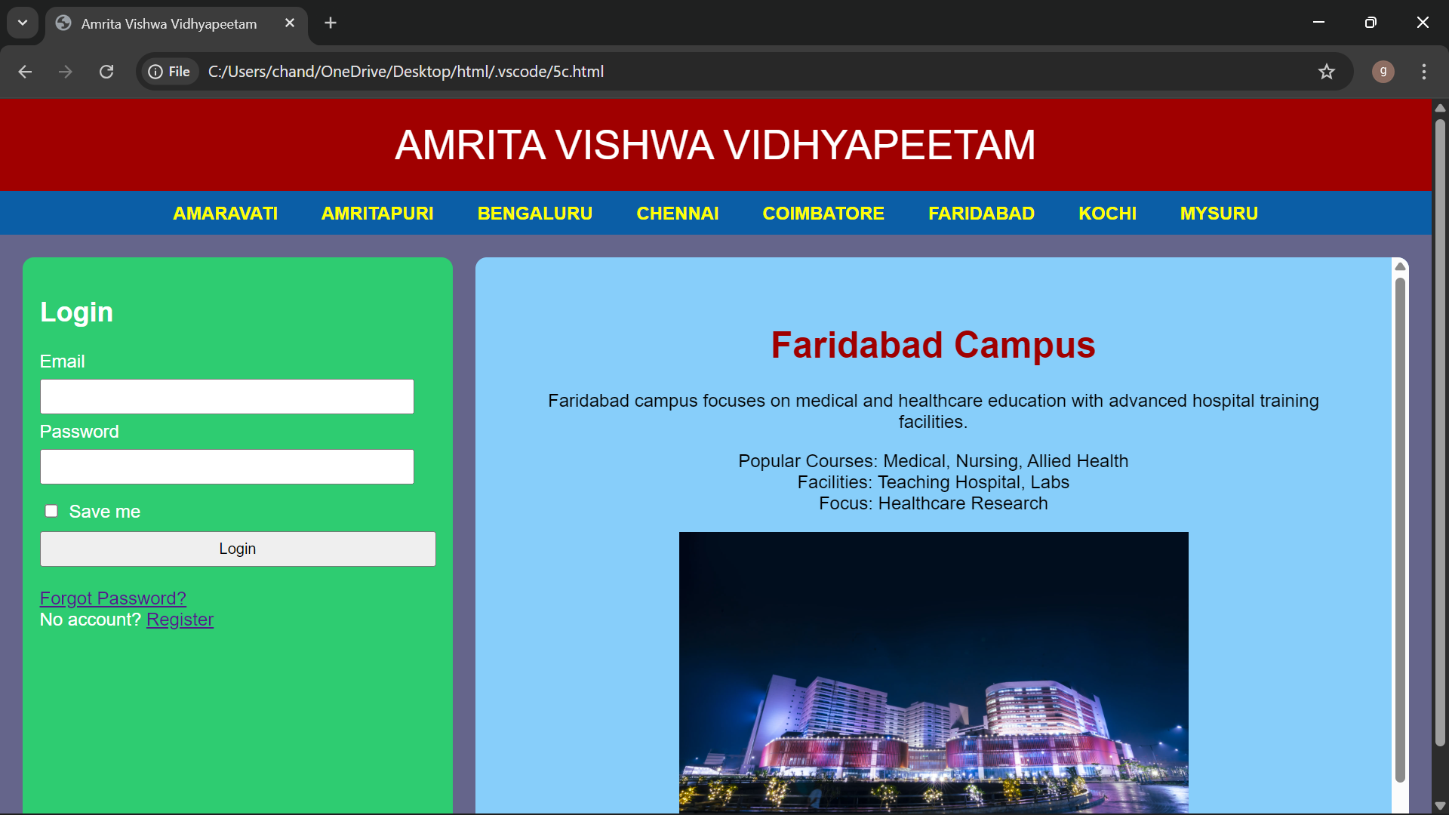

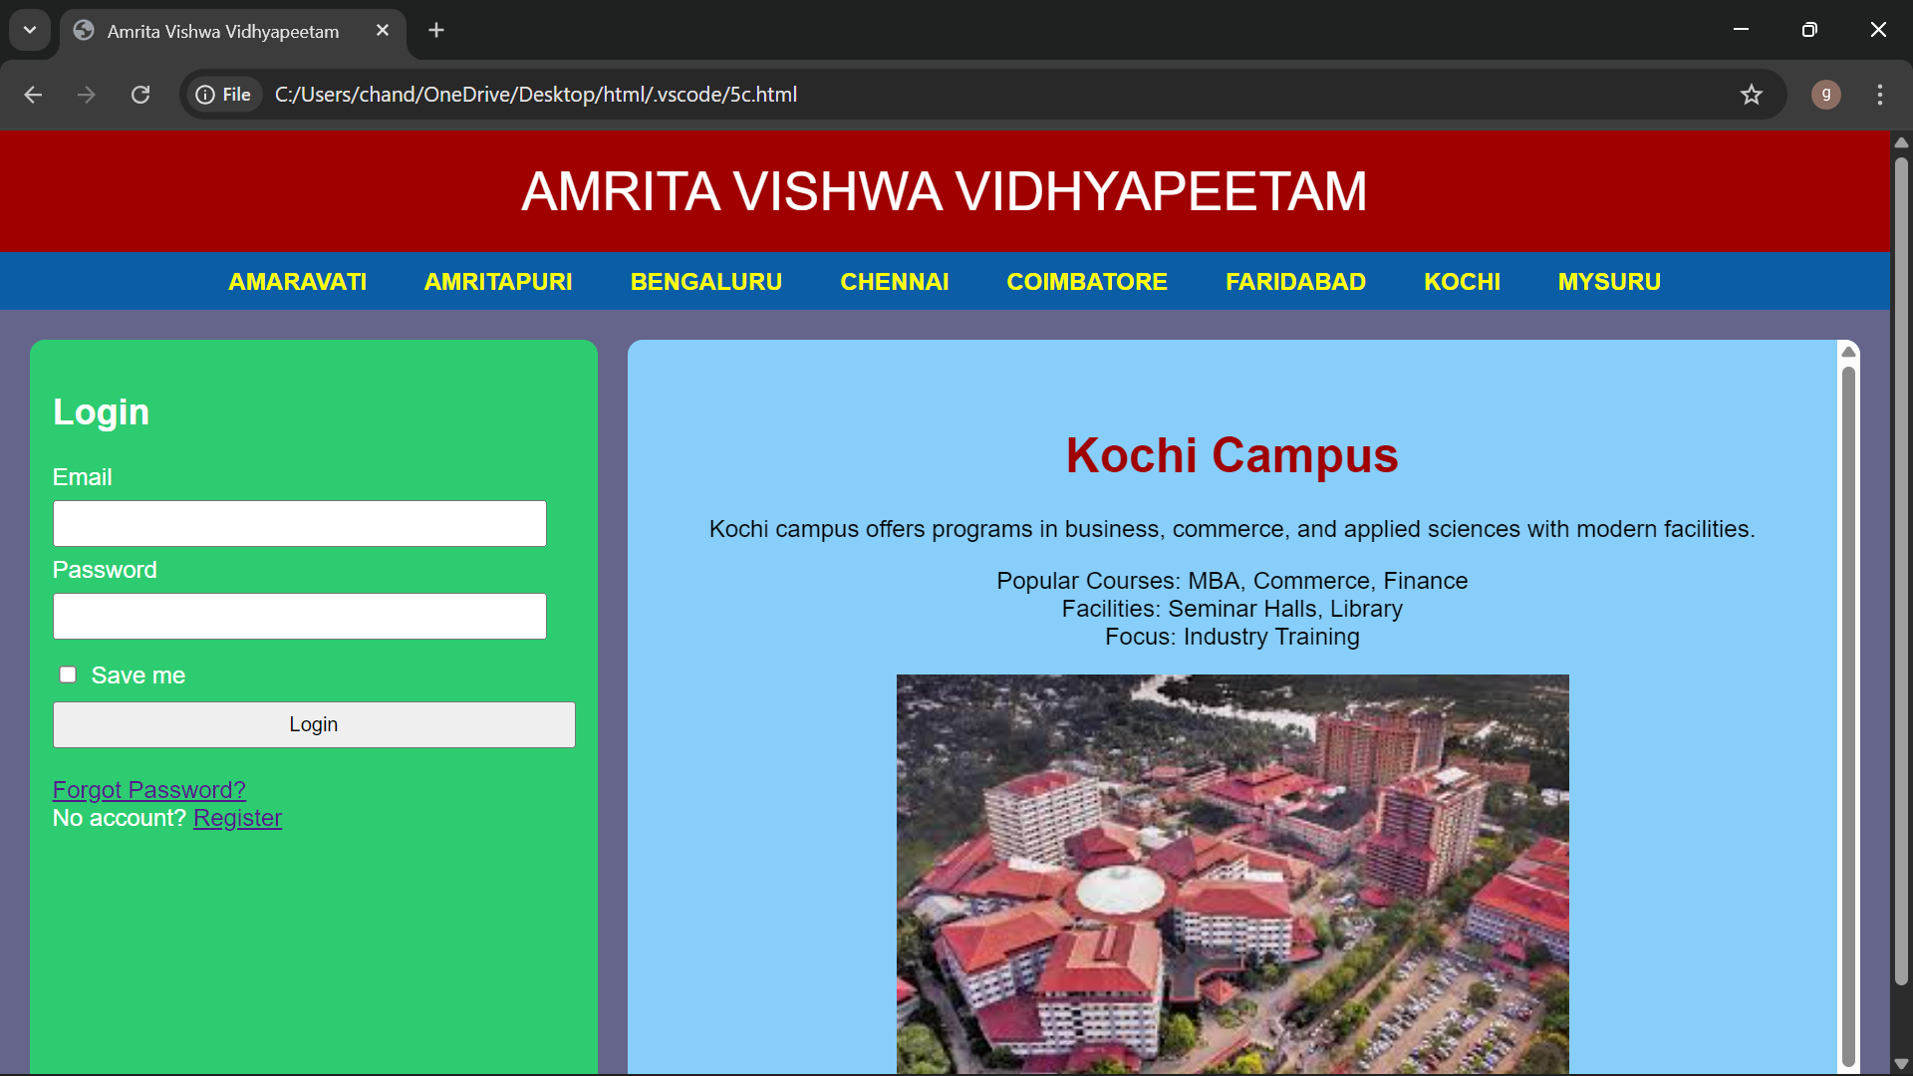

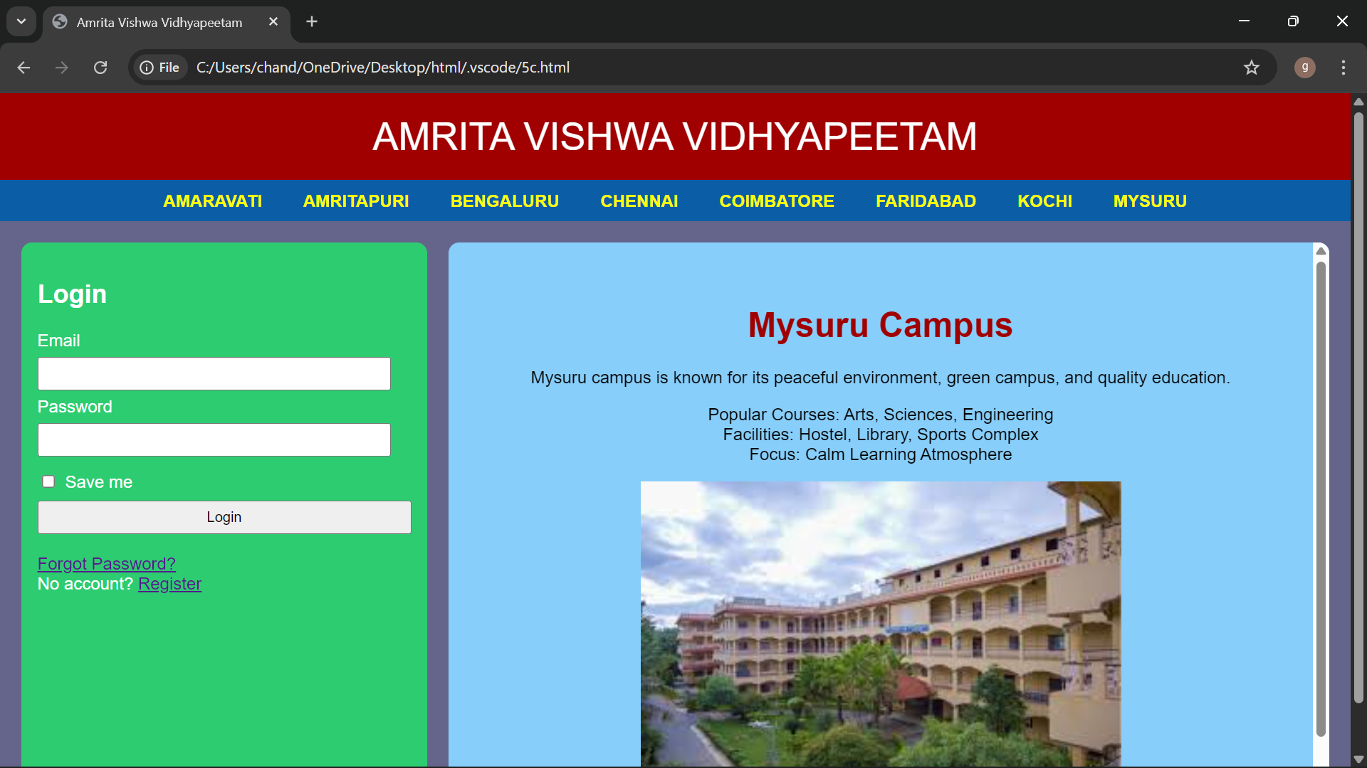

Explanation of the tags:
<DOCTYPE html> : the <!DOCTYPE html> element tells the web browser that this an HTML document or this is the latest version of HTML
<html> : the <html> element is the root element of an HTML web page
<head> : the <head> element will contain meta data about the HTML web page
<title> : the <title> element specifies a title for the HTML Page
<body> : the <body> element contains all visible content all visible content like text , image , links , tables , etc
<h> : we used <h> element for heading

<p> : we used <p> element for the paragraph
<div>:we use <div> element for encapsulating the the divisions and easy to modify and
<button>: we use <button> element for button
<img>: we use <img> tag for displaying the image

WEEK -6

Aim: A.Design a responsive e-commerce application using the grid layout. This application should
contain different categories of products such as electronics, clothing, home-appliances, books.
B: Design a responsive e-commerce application using the grid layout. This application should
contain different categories of products such as electronics, clothing, home-appliances, books.
Based on the category we select corresponding products should be displayed on the sidebar.
6 A)
Program:
<!DOCTYPE html>
<html>
<head>
<title>My Gaming Store</title>

<style>
body{
font-family: Arial, sans-serif;
margin: 0;
padding: 0;
background-color: rgb(0, 137, 250);
}

/* GRID */
.container{
display: grid;
grid-template-rows: auto auto 1fr auto;
grid-template-columns: 200px 1fr;
grid-template-areas:
"header header"
"sale sale"
"sidebar main"
"footer footer";
gap: 10px;
padding: 10px;
}

/* SECTIONS */
.header{
grid-area: header;
background-color: rgb(64, 0, 255); /* FIXED */
padding: 10px;
text-align: center;
color: white;
}

.sale{
grid-area: sale;
background-color: white;
padding: 10px;
text-align: center;
font-weight: bold;
}

.sidebar{
grid-area: sidebar;
background-color: white;
padding: 10px;
}

.main{
grid-area: main;
background-color: white;
padding: 10px;
display: grid;
grid-template-columns: repeat(2, 1fr);
gap: 10px;
}

.footer{
grid-area: footer;
background-color: white;
padding: 10px;
text-align: center;
}

/* PRODUCT */
.product{
background-color: #f9f9f9;
padding: 10px;
border-radius: 5px;
text-align: center;
}

.product-image{
width: 150px;
height: 150px;
object-fit: cover;
}

/* BUTTON */
.button{
background-color: white;
color: blue;
border: 2px solid blue;
padding: 10px 20px;
border-radius: 5px;
cursor: pointer;
}

.button:hover{
background-color: blue;
color: white;
}
</style>
</head>

<body>

<div class="container">

<div class="header">
<h1>The Gaming Paradise</h1>
</div>

<div class="sale">
<p>🔥 BIG SALE 46% OFF 🔥</p>
</div>

<div class="sidebar">
<h2>Store</h2>
<ul>
<li>Forza Horizon 5</li>
<li>John Wick</li>
<li>Resident Evil 9</li>
<li>Black Myth Wukong</li>
</ul>
</div>

<div class="main">

<div class="product">
<img class="product-image" src="https://via.placeholder.com/150">
<h3>Forza Horizon 5</h3>
<p>Price: $50</p>
<button class="button">Add to Cart</button>
</div>

<div class="product">
<img class="product-image" src="https://via.placeholder.com/150">
<h3>John Wick</h3>
<p>Price: $90</p>
<button class="button">Add to Cart</button>
</div>

<div class="product">
<img class="product-image" src="https://via.placeholder.com/150">
<h3>Resident Evil 9</h3>
<p>Price: $120</p>
<button class="button">Add to Cart</button>
</div>

<div class="product">
<img class="product-image" src="https://via.placeholder.com/150">
<h3>Black Myth Wukong</h3>
<p>Price: $150</p>
<button class="button">Add to Cart</button>
</div>

</div>

<div class="footer">
<p>@2026 My Gaming Store. All rights reserved.</p>
</div>

</div>

</body>
</html>
Output:

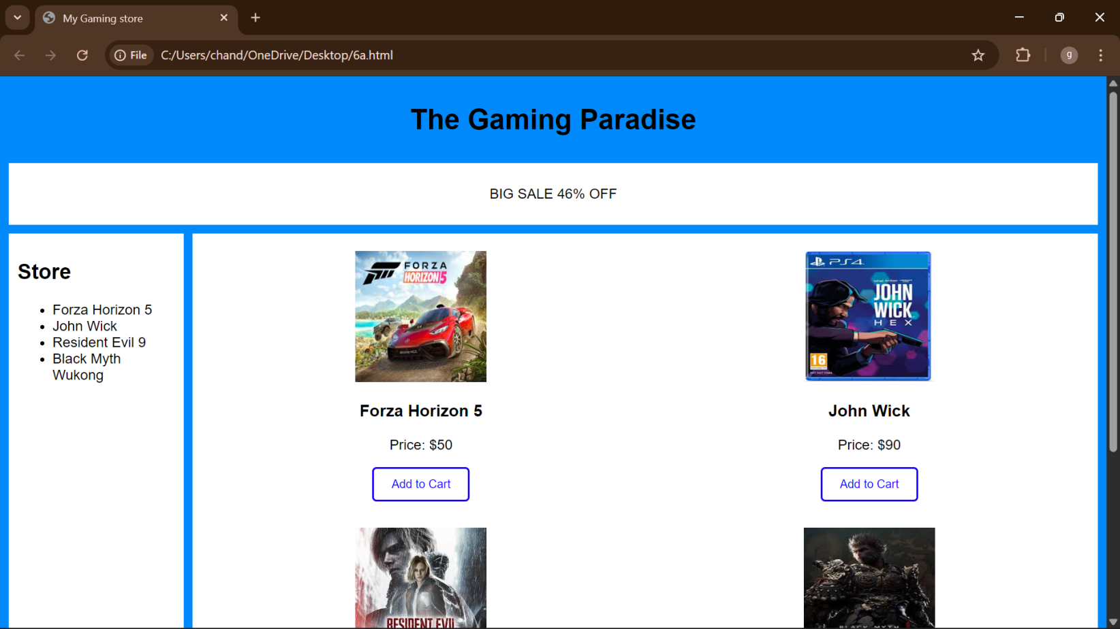
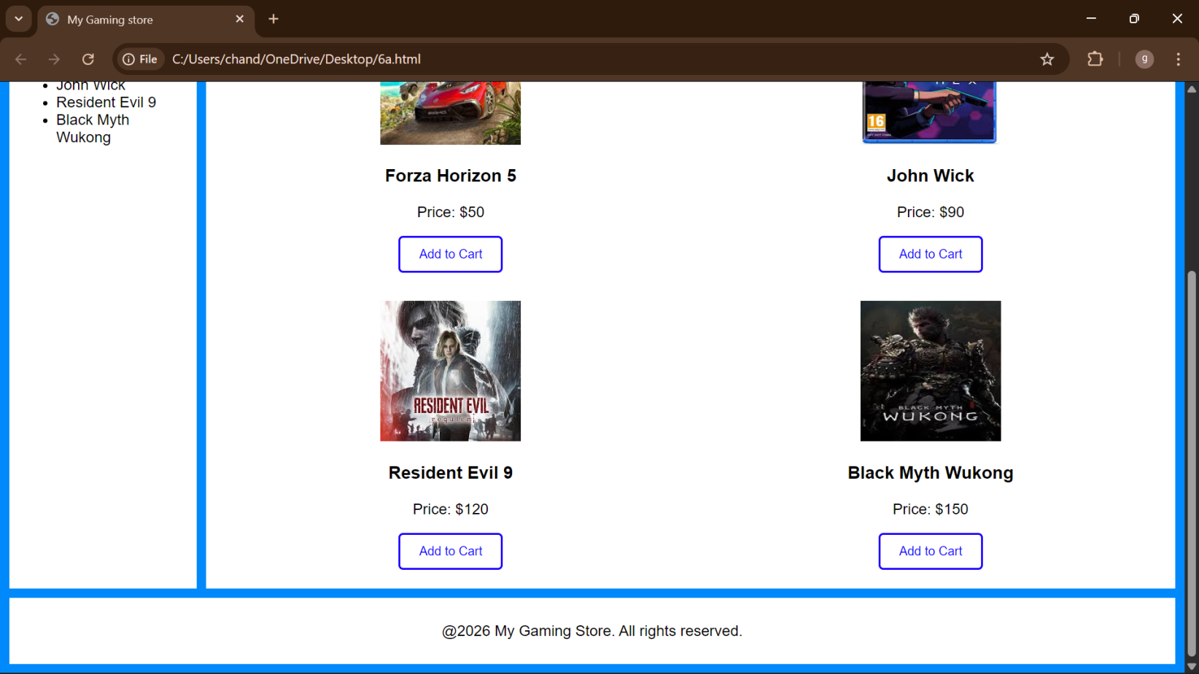
Explanation of the tags:
<DOCTYPE html> : the <!DOCTYPE html> element tells the web browser that this an HTML document or this is the latest version of HTML
<html> : the <html> element is the root element of an HTML web page
<head> : the <head> element will contain meta data about the HTML web page
<title> : the <title> element specifies a title for the HTML Page
<body> : the <body> element contains all visible content all visible content like text , image , links , tables,etc
<h> : we used <h> element for heading
<p> : we used <p> element for the paragraph
<div>:we use <div> element for encapsulating the the divisions and easy to modify and
<button>: we use <button> element for button
<img>: we use <img> tag for displaying the image
6 B)
Program:
<!DOCTYPE html>
<html>
<head>
<title>My Gaming Store</title>
<style>
body{
margin:0;
font-family:Arial;
color:#fff;
background:url("backgroundimages.jpg") center/cover fixed no-repeat;
}

/* Dark overlay */
body::before{
content:"";
position:fixed;
inset:0;
background:rgba(0,0,0,.75);
z-index:-1;
}

/* GRID */
.container{
display:grid;
grid-template:
"header header" auto
"sale sale" auto
"sidebar main" 1fr
"footer footer" auto /220px 1fr;
gap:15px;
padding:15px;
}

/* COMMON STYLE */
.header,.sale,.sidebar,.main,.footer{
background:rgba(40,40,40,.65);
border-radius:12px;
padding:15px;
box-shadow:0 0 15px #000;
}

/* HEADER */
.header{
grid-area:header;
text-align:center;
font-size:28px;
letter-spacing:3px;
}

/* SALE ANIMATION */
.sale{
grid-area:sale;
overflow:hidden;
white-space:nowrap;
height:40px;
position:relative;
}

.sale p{
position:absolute;
color:#00ffd5;
font-size:20px;
animation:move 10s linear infinite;
}

@keyframes move{
from{left:-100%;}
to{left:100%;}
}

/* SIDEBAR */
.sidebar{
grid-area:sidebar;
}

.sidebar ul{
list-style:none;
padding:0;
}

.sidebar li{
margin:15px 0;
}

.sidebar a{
color:#fff;
text-decoration:none;
font-size:18px;
transition:.3s;
}

.sidebar a:hover{
color:#00ffd5;
padding-left:8px;
}

/* MAIN */
.main{
grid-area:main;
}

iframe{
width:100%;
height:520px;
border:0;
background:rgba(0,0,0,.5);
border-radius:10px;
}

/* FOOTER */
.footer{
grid-area:footer;
text-align:center;
font-size:14px;
opacity:.85;
}
</style>
</head>

<body>

<div class="container">

<div class="header">My Gaming Paradise</div>

<div class="sale">
<p>BIG SALE 46% OFF</p>
</div>

<div class="sidebar">
<h2>Categories</h2>
<ul>
<li><a href="Forza Horizon 5.html" target="contentFrame">Forza Horizon 5</a></li>
<li><a href="John Wick.html" target="contentFrame">John Wick</a></li>
<li><a href="Resident Evil 9.html" target="contentFrame">Resident Evil 9</a></li>
<li><a href="Black Myth Wukong.html" target="contentFrame">Black Myth Wukong</a></li>
</ul>
</div>

<div class="main">
<iframe name="contentFrame"></iframe>
</div>

<div class="footer">
The Gaming Paradise
</div>

</div>

</body>
</html>
Sub1:
<!DOCTYPE html>
<html>
<head>
<title>Forza Horizon 5</title>
<style> body{
font-family: Arial, sans-serif;
margin:0;
padding:20px; background-color: gray;
}
.container{
display:grid;
grid-template-columns: 1fr 1fr; /* 2 columns */ grid-template-rows: auto auto; /* 2 rows */ gap:20px;
}
.card{
background:white; padding:20px; border-radius:10px;
box-shadow:0 4px 10px rgba(0,0,0,0.2); text-align:center;
}
.card-img{
width:200px; height:200px; border-radius:10px; margin-bottom:10px;
}
.price{
font-size:18px; color:green; margin-top:10px;
}
</style>
</head>
<body>
<div class="container">
<div class="card">
<img class="card-img" src="C:\Users\chand\Downloads\fh car1.jpeg">
<h2>Bronco</h2>
<p class="price">$1.99</p>
</div>
<div class="card">
<img class="card-img" src="C:\Users\chand\Downloads\fh car 2.jpeg">
<h2>Koenigsegg jesko</h2>
<p class="price">$4.99</p>
</div>
</div>
</div>
</body>
</html>

Sub 2:
<!DOCTYPE html>
<html>
<head>
<title>John Wick</title>
<style> body{
font-family: Arial, sans-serif;
margin:0;
padding:20px; background-color: gray;
}
.container{
display:grid;
grid-template-columns: 1fr 1fr; /* 2 columns */ grid-template-rows: auto auto; /* 2 rows */ gap:20px;
}
.card{
background:white; padding:20px; border-radius:10px;
box-shadow:0 4px 10px rgba(0,0,0,0.2); text-align:center;
}
.card-img{
width:200px; height:200px; border-radius:10px; margin-bottom:10px;
}
.price{
font-size:18px; color:green; margin-top:10px;
}
</style>
</head>
<body>
<div class="container">
<div class="card">
<img class="card-img" src="C:\Users\chand\Downloads\gun 1.jpeg">
<h2>Gun 1</h2>
<p class="price">$0.99</p>
</div>
<div class="card">
<img class="card-img" src="C:\Users\chand\Downloads\gun 2.jpeg">
<h2>Gun 2</h2>
<p class="price">$1.99</p>
</div>
</div>
</div>
</body>
</html>
Sub 3:
<!DOCTYPE html>
<html>
<head>
<title>Resident Evil 9</title>
<style> body{
font-family: Arial, sans-serif;
margin:0;
padding:20px; background-color: gray;
}
.container{
display:grid;
grid-template-columns: 1fr 1fr; /* 2 columns */ grid-template-rows: auto auto; /* 2 rows */ gap:20px;
}
.card{
background:white; padding:20px; border-radius:10px;
box-shadow:0 4px 10px rgba(0,0,0,0.2); text-align:center;
}
.card-img{
width:200px; height:200px; border-radius:10px; margin-bottom:10px;
}
.price{
font-size:18px; color:green; margin-top:10px;
}
</style>
</head>
<body>
<div class="container">
<div class="card">
<img class="card-img" src="C:\Users\chand\Downloads\gun 4.jpeg">
<h2>Gun 1</h2>
<p class="price">$5</p>
</div>
<div class="card">
<img class="card-img" src="C:\Users\chand\Downloads\gun3.jpeg">
<h2>Gun 2</h2>
<p class="price">$4</p>
</div>
</div>
</div>
</body>
</html>
Sub 4:
<!DOCTYPE html>
<html>
<head>
<title>Black Myth Wukong</title>
<style> body{
font-family: Arial, sans-serif;
margin:0;
padding:20px; background-color: gray;
}
.container{
display:grid;
grid-template-columns: 1fr 1fr; /* 2 columns */ grid-template-rows: auto auto; /* 2 rows */ gap:20px;
}
.card{
background:white; padding:20px; border-radius:10px;
box-shadow:0 4px 10px rgba(0,0,0,0.2); text-align:center;
}
.card-img{
width:200px; height:200px; border-radius:10px; margin-bottom:10px;
}
.price{
font-size:18px; color:green; margin-top:10px;
}
</style>
</head>
<body>
<div class="container">
<div class="card">
<img class="card-img" src="C:\Users\chand\Downloads\armor 1.jpeg">
<h2>Armor 1</h2>
<p class="price">$2</p>
</div>
<div class="card">
<img class="card-img" src="C:\Users\chand\Downloads\Armor 2.jpeg">
<h2>Armor 2</h2>
<p class="price">$3</p>
</div>
</div>
</div>
</body>
</html>
Output:
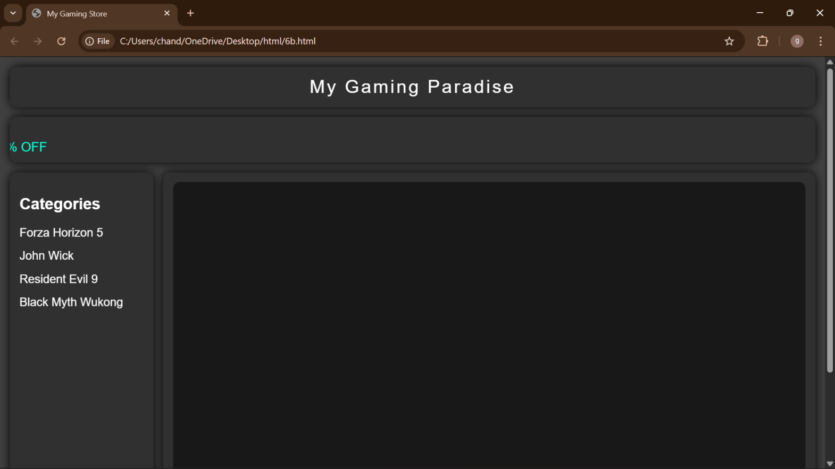

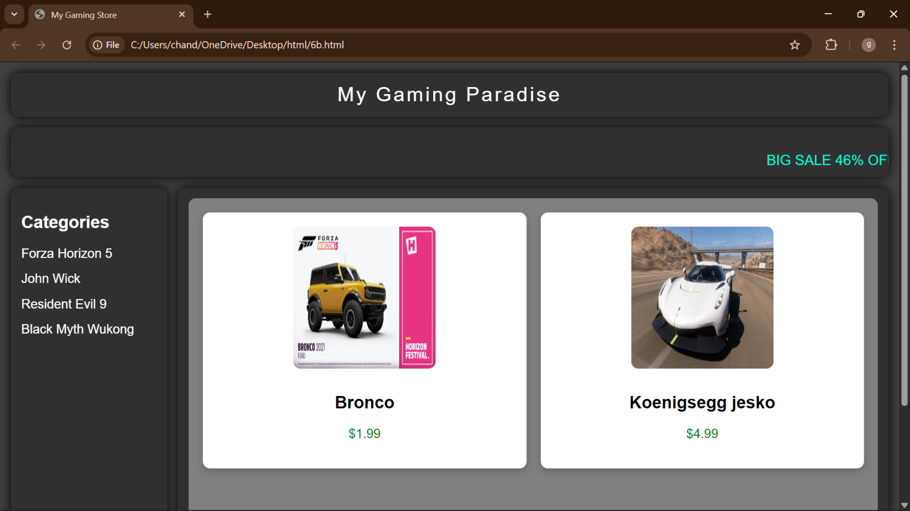
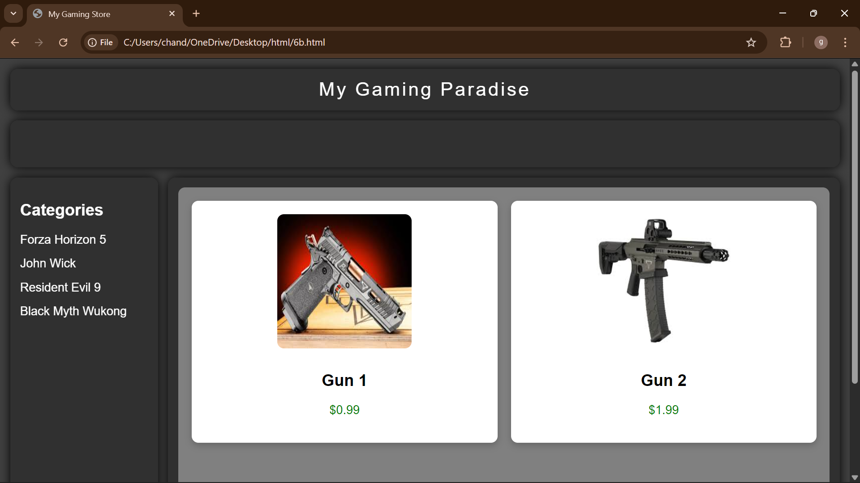

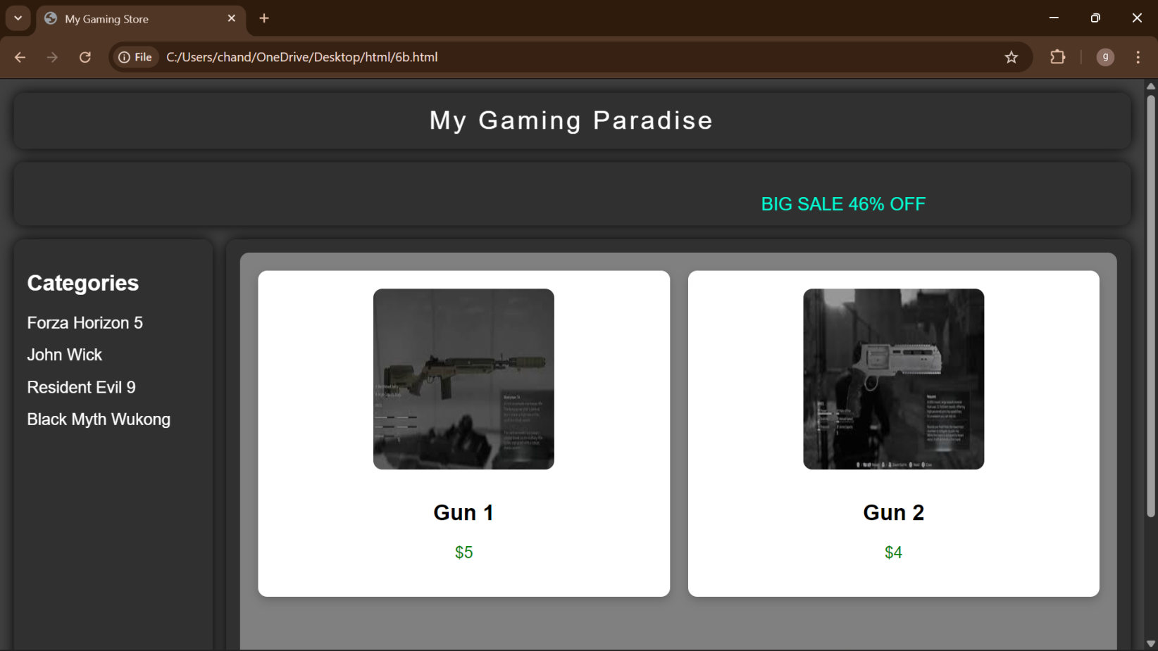

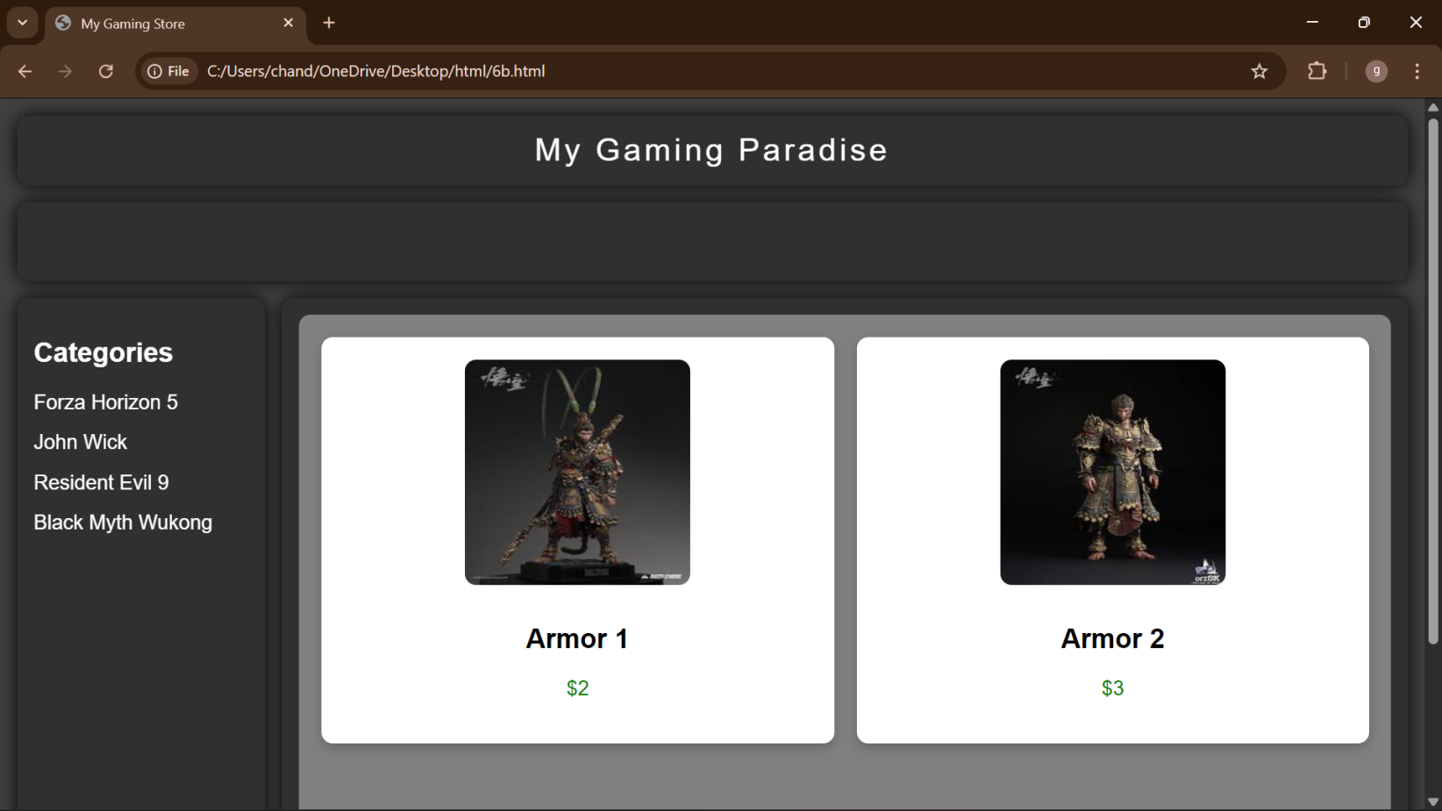

Explanation of the tags:
<html> : the <html> element is the root element of an HTML web page
<head> : the <head> element will contain meta data about the HTML web page
<title> : the <title> element specifies a title for the HTML Page
<body> : the <body> element contains all visible content all visible content like text , image , links , tables , etc
<h> : we used <h> element for heading
<p> : we used <p> element for the paragraph
<div>:we use <div> element for encapsulating the the divisions and easy to modify and
<button>: we use <button> element for button
<img>: we use <img> tag for displaying the image
<I frame>:we <iframe> tag to create link other webpages into it.

WEEK -7

Aim: Create a GitHub account and create a repository in it and push all the week 6 code files in it.
Procedure :
Step 1: browse for GitHub and enter it.
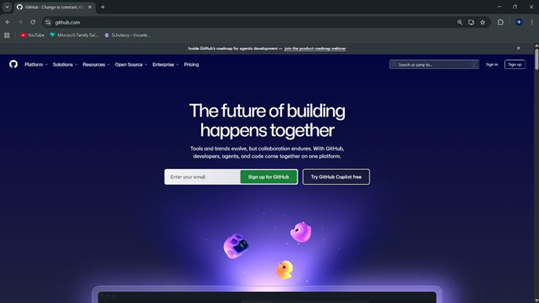
Step 2:login to GitHub account.
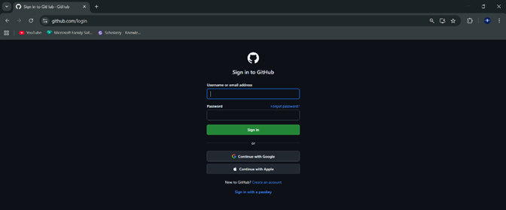
Step3: create a repository after login by clicking new.
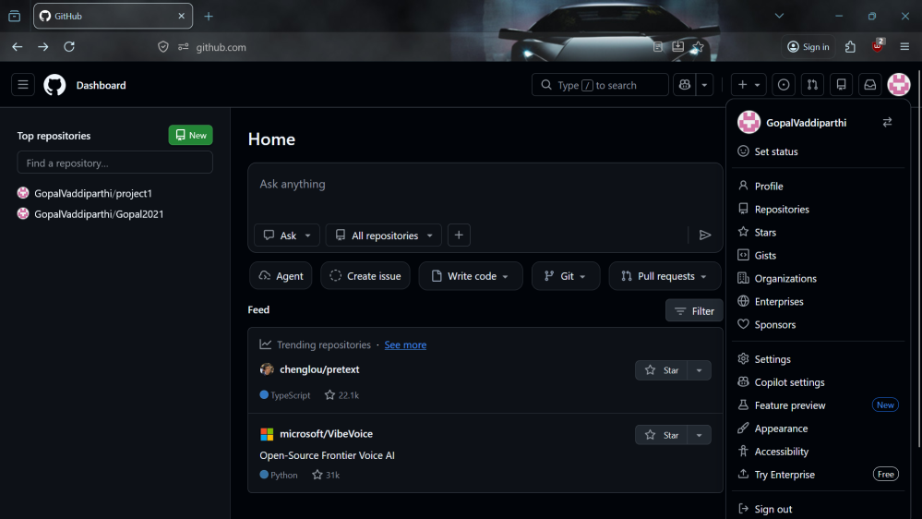

Step 4:specify the repository specifications.
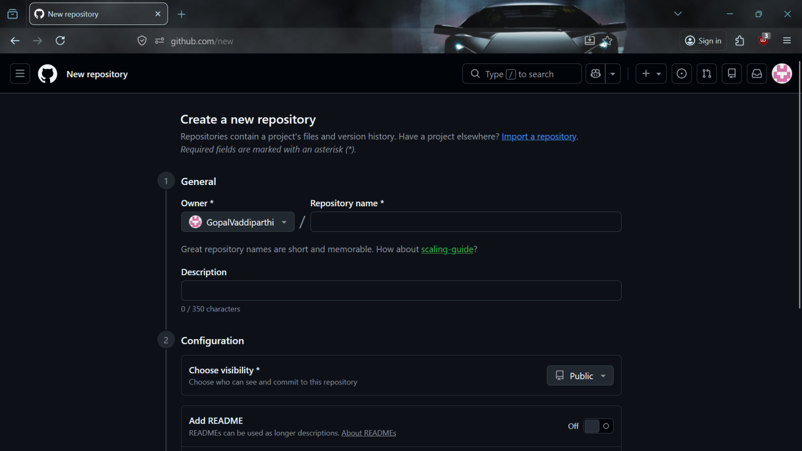
Step 5:download GitHub desktop and Lauch it .
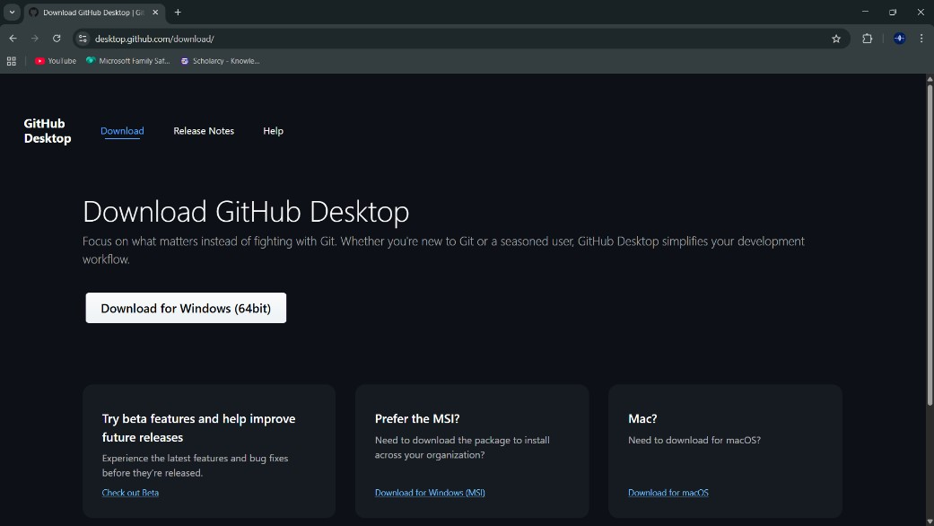
Step 6:add the repository to it .
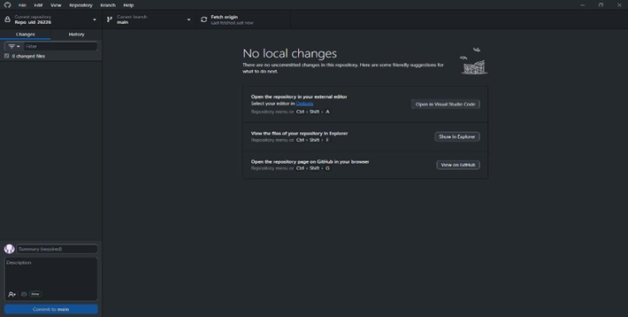

Step 7:add files from vs code
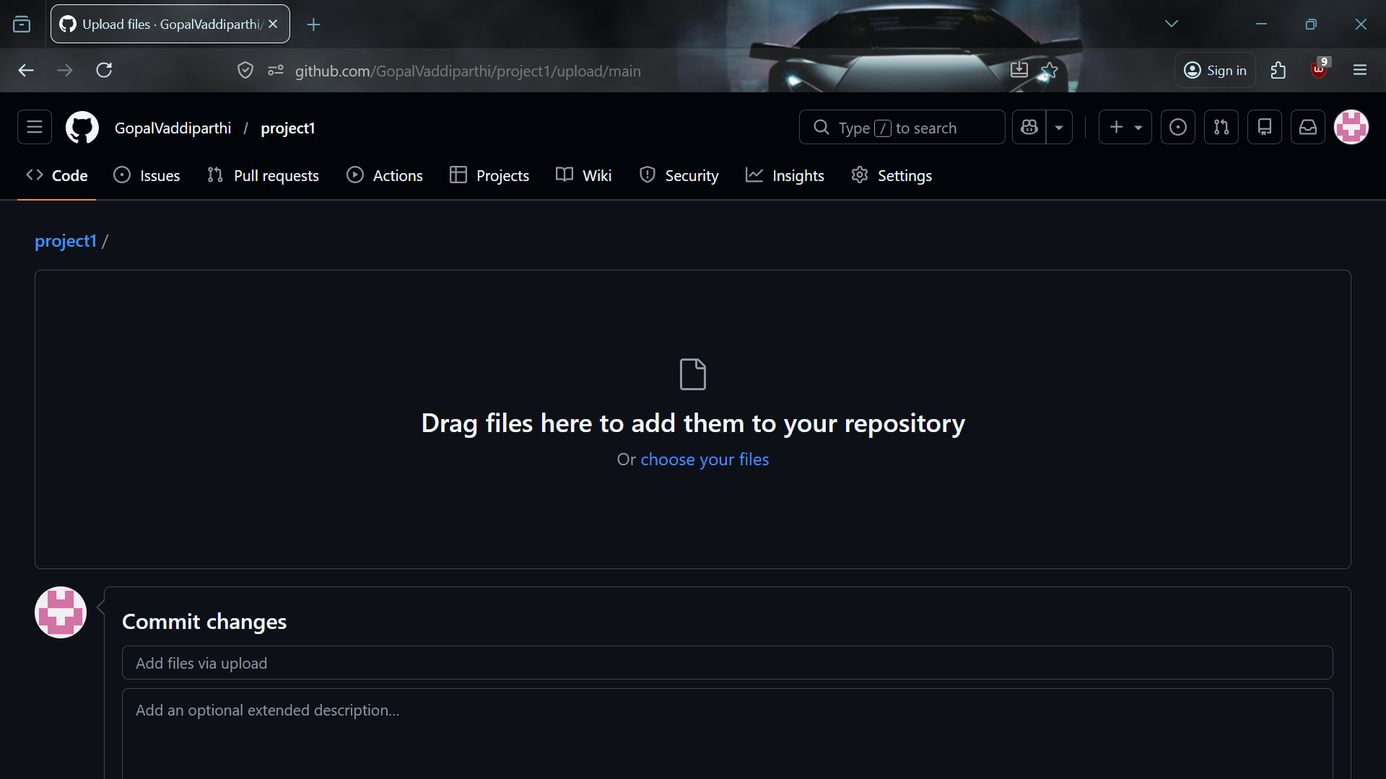

My repository link for the uid all week’s work:
https://github.com/GopalVaddiparthi/project1?tab=readme-ov-file#project1

WEEK -8

8A) Aim: create a web page that displays a square that continuously rotates 360 using css animation
Program:
<!DOCTYPE html>
<html>
<head>
<title>Rotating Square</title>
<style>
body {
margin: 0;
height: 100vh;
display: flex;
flex-direction: column;
justify-content: flex-start;
align-items: center;
background-color: #2f3e46;
font-family: Arial, sans-serif;
padding-top: 50px;
}
.square {
width: 120px;
height: 120px;
background: #ffffffcc;
border-radius: 12px;
box-shadow: 0 8px 25px rgba(0, 0, 0, 0.2);
animation: rotate 3s linear infinite;
}
@keyframes rotate {
from {
transform: rotate(0deg);
}
to {
transform: rotate(360deg);
}
}
</style>
</head>
<body>
<h1 style="color: #fff;">Rotating Square</h1>
<div class="square"></div>
</body>
</html>
Output:
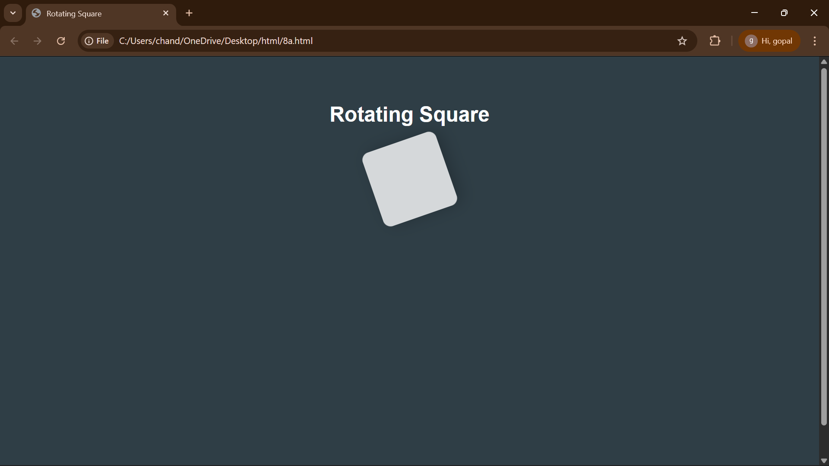

Explanation of the tags:
<DOCTYPE html> : the <!DOCTYPE html> element tells the web browser that this an HTML document
or this is the latest version of HTML
<html> : the <html> element is the root element of an HTML web page
<head> : the <head> element will contain meta data about the HTML web page
<title> : the <title> element specifies a title for the HTML Page
<body> : the <body> element contains all visible content all visible content like text , image , links ,
tables , etc
<h> : we used <h> element for heading
<div>:we use <div> element for encapsulating the the divisions and easy to modify and
@keyframes:we use @keyframes for animation from starting to end transformation.
We used animation shorthand property for these things to mention the animations preferences and
use keyframes for mentioning the positions of the animation and used style attribute and some value
properties for look and we used internal css in it .

8B)Aim: create a ball that moves up and down continuously using css animation
Program:
<!DOCTYPE html>
<html>
<head>
<title>Bouncing Ball</title>
<style>
body {
margin: 0;
height: 100vh;
display: flex;
flex-direction: column;
align-items: center;
justify-content: flex-start;
background: #2f3e46;
}
h1 {
margin-top: 20px;
color: #ffffff;
}
.ball {
width: 80px;
height: 80px;
background: #ffffff;
border-radius: 50%;
margin-top: 120px;
animation: bounce 1.5s ease-in-out infinite;
}
@keyframes bounce {
0% {
transform: translateY(0);
}
50% {
transform: translateY(-120px);
}
100% {
transform: translateY(0);
}
}
</style>
</head>
<body>
<h1>Bouncing Ball</h1>
<div class="ball"></div>
</body>
</html>

Output:
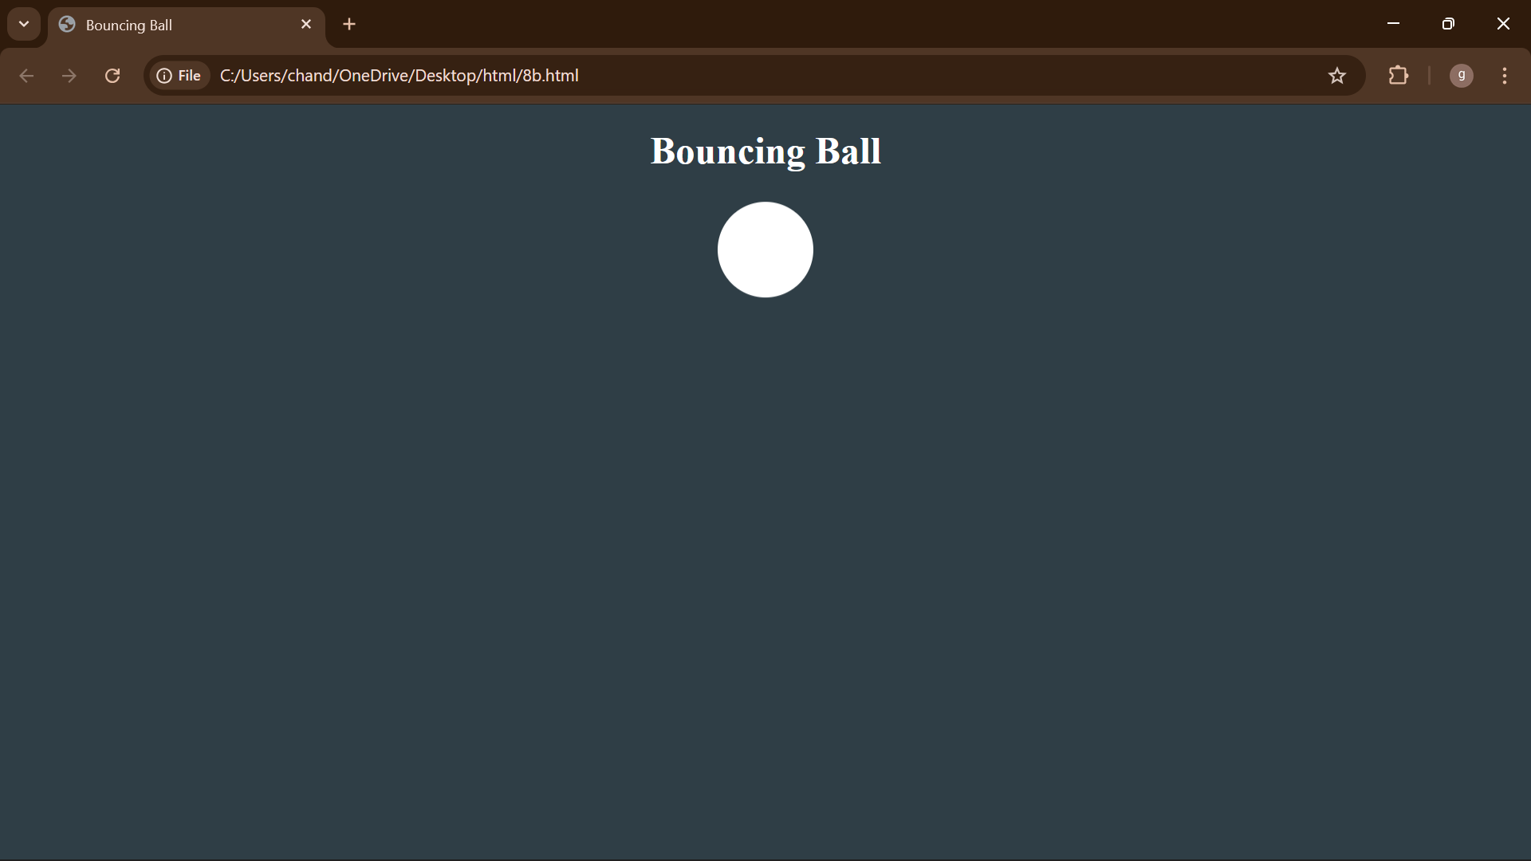

Explanation of the tags:
<DOCTYPE html> : the <!DOCTYPE html> element tells the web browser that this an HTML document
or this is the latest version of HTML
<html> : the <html> element is the root element of an HTML web page
<head> : the <head> element will contain meta data about the HTML web page
<title> : the <title> element specifies a title for the HTML Page
<body> : the <body> element contains all visible content all visible content like text , image , links ,
tables , etc
<h> : we used <h> element for heading
<div>:we use <div> element for encapsulating the the divisions and easy to modify

8C)Aim: create a circle that moves horizontally and rotates At the same time
Program:
<!DOCTYPE html>
<html lang="en">
<head>
<title>Moving Rotating Circle</title>
<style>
body {
margin: 0;
height: 100vh;
display: flex;
flex-direction: column;
align-items: center;
justify-content: flex-start;
background: #2f3e46;
overflow: hidden;
}
h1 {
margin-top: 20px;
color: #ffffff;
}
.circle {
width: 80px;
height: 80px;
background: #ffffff;
border-radius: 50%;
margin-top: 120px;
animation: moveRotate 3s linear infinite;
}
@keyframes moveRotate {
0% {
transform: translateX(-150px) rotate(0deg);
}
50% {
transform: translateX(150px) rotate(180deg);
}
100% {
transform: translateX(-150px) rotate(360deg);
}
}
</style>
</head>
<body>
<h1>Moving Rotating Circle</h1>
<div class="circle"></div>
</body>
</html>
Output:
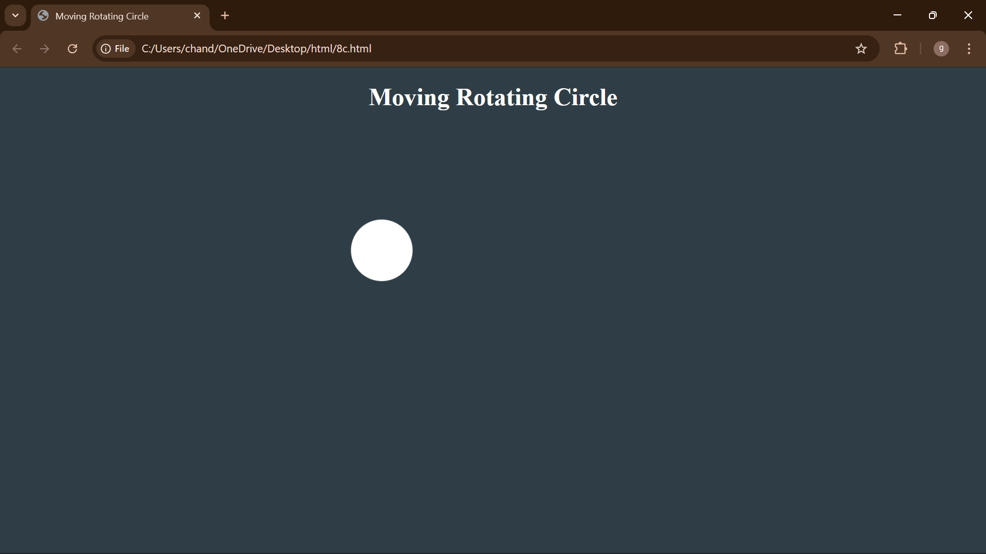

Explanation of the tags:
<DOCTYPE html> : the <!DOCTYPE html> element tells the web browser that this an HTML document
or this is the latest version of HTML
<html> : the <html> element is the root element of an HTML web page
<head> : the <head> element will contain meta data about the HTML web page
<title> : the <title> element specifies a title for the HTML Page
<body> : the <body> element contains all visible content all visible content like text , image , links ,
tables , etc
<h> : we used <h> element for heading
<div>:we use <div> element for encapsulating the the divisions and easy to modify

